Abstract
When people learn that a transgressive act has occurred, their responses to that act (e.g., judgements of moral wrongness, assignments of punishment) are often characterized by intergroup bias; they respond more harshly to outgroup transgressions than ingroup transgressions. Prior work shows that the stronger one’s ingroup identity, the greater this intergroup bias tends to be. In the present work, we investigated how social identity complexity, the relationships between one’s ingroup identity and their other social identities, may influence this bias. People whose identities are tightly overlapping, who are low in identity complexity, have been shown to display greater intergroup prejudice. Therefore, we hypothesized that the less one’s ingroup identity overlaps with their other social identities (i.e., the greater their identity complexity), the less intergroup bias they will display in their moral judgments. We hypothesized that this effect would be driven by perceiving transgressors to be less typical group members, less representative of their groups as a whole, mitigating the influence of group biases on judgments. Across three studies (N = 2,484), we found that social identity complexity was associated with judging outgroup members less harshly and ingroup transgressors more harshly, and that this was mediated by perceiving both ingroup and outgroup transgressors as less typical group members. We demonstrate the robustness of these effects across political and religious contexts and show how social identity complexity is associated with the Black Sheep effect in some cases.

Introduction
When people learn that a moral violation has occurred, their responses, including judgments of wrongness and assignments of punishment, are often characterized by intergroup bias. That is, people tend to evaluate transgressions committed by outgroup members more harshly than those committed by ingroup members (Abrams et al., 2013; Valdesolo & DeSteno, 2007). People also tend to assign more punishment to outgroup transgressors compared to ingroup transgressors (Yudkin et al., 2016; Schiller et al., 2014). Intergroup bias in moral judgment may be motivated by a desire to maintain a positive view of oneself and one’s group relative to the outgroup, a view which can be threatened by learning about a moral violation committed by an ingroup member (van der Toorn et al., 2015; Chekroun & Nugier, 2011). This motivation is likely to be highest among those who are most attached to the ingroup; indeed, prior work finds that stronger identification with the ingroup and the belief that one’s ingroup is superior are associated with greater bias in moral judgment (Bocian et al., 2021). Research on the impact of social identity on moral judgment has largely focused on one lever of change: the single salient identity. Therefore, it is not well understood how relationships between the salient identity and an individual’s multiple other social identities influence moral judgment. However, prior work suggests that these relationships are also key levers in shaping intergroup attitudes; holding highly overlapping identities may exacerbate intergroup bias, whereas holding minimally overlapping identities may mitigate against it. In the current work, we examine the impact of social identity complexity (SIC; Roccas & Brewer, 2002)—the perceived overlap and similarity of individuals’ multiple social identities—on intergroup bias in moral judgment.
Those who perceive their multiple social groups to be highly similar and highly overlapping (i.e., members of one of their social groups also tend to be members of their other social groups) are considered to have low social identity complexity. For instance, a white, conservative, male Christian may perceive their social groups as being comprised of many of the same people and that those people tend to share many attributes. In contrast, those who perceive their multiple social groups to be less similar and minimally overlapping (i.e., members of one of their social groups do not tend to also belong to their other social groups) are considered to have high social identity complexity. For instance, liberal Christians and black Republicans may perceive their social groups as being largely comprised of different people and that these people have largely unique characteristics. People high in SIC are theorized to perceive ingroup boundaries to be more flexible, to have greater exposure to and positive contact with outgroup members, and to have greater self-concept flexibility, mitigating against harmful biases and prejudices toward outgroup members (Roccas & Brewer, 2002; Brewer, 2010). Indeed, prior work demonstrates that SIC is associated with lower prejudice, greater tolerance, and warmer attitudes toward outgroup members (Knifsend & Juvonen, 2014; Miller et al., 2009; Schmid et al., 2009).
Research directly investigating the impact of SIC on moral judgment across group boundaries is limited. Costabile & Austin (2021) examined whether SIC would impact the guilt and shame of students in response to a campus riot. Students who were highly identified with the ingroup (i.e., the university) tended to react defensively, showing less guilt and shame in response to the riot. Importantly, however, highly identified students who were high in SIC reported more guilt and shame, suggesting SIC may mitigate against the self-image threats posed by ingroup transgressions, promoting less biased and more critical responses. One way that SIC may buffer against these threats is by enabling participants to shift their locus of identity—the primary identity on which they are relying for a positive sense of self and belonging—when one of their identities is threatened (Gresky et al., 2005). In contrast, examining attributions of motives and punishment to social deviants in Israel, Roccas and colleagues (2022) found that greater SIC was associated with perceiving deviant ingroup members as being more likely to have acted in the interest of the ingroup and in, turn, assigning them less punishment. These results suggest that reduced ingroup threat among people with high SIC may not always contribute to greater criticism of ingroup transgressors and may, in fact, lead to less criticism.
In the current work, we extend prior work on the impact of social identity on moral judgment by clarifying the impact of SIC on judgments of ingroup transgressors and conducting the first examination of the impact of SIC on judgments of outgroup transgressors, enabling us to examine the impact of SIC on intergroup bias in moral judgment. We also investigate the extent to which the effects of SIC on moral judgment are influenced by individuals’ perceptions of the typicality of the transgressors.
Perceived typicality plays a key role in intergroup cognition, including attitude formation and stereotype change (Hewstone & Lord, 1997). When people learn information about individual group members that challenges their prior beliefs about a whole group, the extent to which they update their beliefs about the group largely depends on how typical they perceive them to be. When people perceive outgroup transgressors to be less typical, they are less likely to generalize their negative attitudes about the transgressors to the whole outgroup (Meeussen et al., 2013). Atypical transgressors may by subtyped, or viewed as an exception to the norm (Richards & Miles, 2001; Kunda et al., 1995), a process which can be influenced by motivation to maintain existing stereotypes (Derreumaux et al., 2023). Perceived typicality also shapes the extent to which group attitudes influence behavior towards individual group members. For instance, group attitudes have a stronger impact on behavior toward typical group members than atypical group members (Lord et al., 1991). This work suggests that perceiving targets as less typical may mitigate the influence of intergroup bias. People often perceive outgroup members to be more stereotypical than ingroup members, which may be driven by the tendency to perceive outgroups as more homogenous than ingroups (Linville & Fischer, 1993). People are more likely to think of group members as highly similar to each other when they perceive the group to be homogeneous (Lambert & Wyer, 1990) and highly entitative (Crawford et al., 2002), having strict boundaries and strong cohesion (Lickel et al., 2000). However, given their own counterstereotypic social identities, people high in SIC may perceive social groups as less entitative and more heterogenous. People high in SIC may be especially less likely to think of outgroups as stereotypical and homogeneous due to greater exposure to a diverse range of outgroup exemplars (Linville & Fischer, 1993), members of the outgroup that inform perceptions of the outgroup. Thus, people high in SIC may be less likely to perceive individual group members as typical of their whole group. In the current work, we examined whether SIC is associated with reduced perceived typicality and whether reduced perceived typicality mediates the effect of SIC on intergroup moral judgments.
Current Studies
We examined the moderating effect of SIC on intergroup bias in moral judgment in three experiments. First, we examined the effects of SIC on a single transgression context (Study 1): a campus riot scenario adapted from prior work for an experimental setting (Costabile & Austin, 2021). Then, we tested the effects across a variety of transgression scenarios, examining participants across different social group boundaries, including politics (Study 2) and religion (Study 3). Across studies, we examined the mediating effect of perceived typicality. All participants were recruited via Prolific and completed the study via Qualtrics. All studies, measures, manipulations, and exclusions are reported in the manuscript or Supplementary Materials. Sample statistics for all studies are reported in Table 1.

Table 1
Sample Characteristics Across Studies
Study | Age  M (SD) | Gender
 |  | Woman | Man | Nonbinary/Other
Study 1  (N = 740) | 41.42 (14.61) | 387 (52.30%) | 336 (45.41%) | 17 (2.30%)
Study 2 (Dem)  (N = 673) | 36.93 (12.74) | 356 (52.90%) | 304 (45.17%) | 13 (1.93%)
Study 2 (Rep)  (N = 533) | 43.14 (14.80) | 273 (51.22%) | 259 (48.59%) | 1 (0.19%)
Study 3  (N = 538) | 41.80 (14.52) | 295 (54.83%) | 235 (43.68%) | 8 (1.49%)

Primary Hypotheses
We hypothesized that SIC would be associated with lower intergroup bias in moral judgment and that this effect would be mediated by perceiving transgressors as less typical group members. These hypotheses were preregistered for Studies 2-3. Pre-registrations for Studies 2 and 3 can be found here: Study 2: https://doi.org/10.17605/OSF.IO/36ZSA; Study 3: https://doi.org/10.17605/OSF.IO/82DFZ. Both preregistrations included the hypotheses, methods, and analysis plan. There was one minor deviation in the sample size for Study 2, which was exceeded due to a Prolific error. All materials, data, and analysis scripts are publicly available: https://osf.io/xj3ed/?view_only=9c2a368c35064eb69502fa56fed415de.
Study 1
In Study 1, we investigated the impact of identity complexity on moral judgments and perceptions of typicality of political ingroup and outgroup members.
Participants
Participants were N = 740 American adults (432 Democrats, 145 Republicans, 163 Independents/Other) recruited and compensated via Prolific for one of three pilot studies. Since the methods and results of the three pilot studies largely converge, we report the combined results. In supplementary analyses, we find that our results hold controlling for study. The results for each individual study can be found in the OSF repository. A sensitivity analysis conducted using the package “pwr” showed that this sample size provided 80% power to detect an R-squared of 0.015 or greater for a regression model with 3 predictors, with an alpha of 0.05.
Procedure
Participants first completed a measure of social identity complexity and then read a vignette depicting a moral transgression. Half of participants were randomly assigned to read that the transgressions were committed by political ingroup members (ingroup condition) and the other half were randomly assigned to read that the transgressions were committed by political outgroup members (outgroup condition). Democrats were shown Republican transgressors in the outgroup condition, and vice-versa for Republicans. Independents were shown “political partisans” in the outgroup condition. The vignette depicted a campus riot scenario based on the focus of Costabile & Austin (2021)’s field study and read as follows:
“Imagine the following:
In response to an upcoming talk scheduled to be delivered at a local college in your area by a controversial speaker, [political ingroup/outgroup] members of the community launch a protest on the campus. The protest breaks out into a riot, resulting in significant damages, estimated around $100,000.”
After the transgression, participants provided moral judgments of the transgression/transgressor, evaluated the typicality of the transgressor as a member of their political group, and indicated how much they would disengage from and lose respect for the transgressor’s political group.
Measures
Social Identity Complexity (SIC)
In line with prior work (e.g., Miller et al., 2009), we examined social identity complexity of four of participants’ important social groups: political affiliation, religion, race, and a fourth identity of their choice (e.g., occupation, hobby, sexual orientation). We used Roccas & Brewer (2002)’s measure of SIC, which assesses two aspects of SIC: membership overlap, which captures the perceived degree of shared membership between one’s social groups, and similarity, which captures the perceived similarity between one’s social groups. We examined the overall SIC of the four identities, as done in prior work, as well as the specific complexity of the salient identity, political affiliation, operationalized as the overlap and similarity of political identity and each of the other three identities (see Figure 1). As preregistered, we expected that the complexity of the salient identity may have stronger effects than overall social identity complexity, given that the relationships between the salient identity and one’s other identities may be more relevant.
Figure. 1
Distinguishing Between Overall Complexity (Left) and Political Complexity (Right)
Overall Complexity: Overlap. Participants indicated how many members of each one of their four social groups are also members of each of their other social groups (e.g., “How many [members of Group A] are also [members of Group B]?”) on an 11-point scale (1 = None are; 6 = Half are; 11 = All are). For each pair of groups, the question was also asked in the alternative direction (e.g., “How many [members of Group B] are also [members of Group A]?”). Scores based on these 11 items were reverse-coded and averaged such that higher scores correspond to lower perceived overlap of one’s groups.
Political Complexity: Overlap. The six items from the above question which included political affiliation (e.g., “How many Democrats are also [members of Group B]?”) were reverse-coded and averaged such that higher scores correspond to lower perceived overlap of one’s political group and their other three groups.
Overall Complexity: Similarity. Participants indicated how similar a typical member of each one of their four social groups are to a typical member of each of their other social groups (e.g., “How similar is a typical [member of Group A] to a typical [member of Group B]?”) on a 7-point scale (1 = Extremely different; 7 = Extremely similar). Scores based on these 6 items were reverse-coded and averaged such that higher scores correspond to lower perceived similarity of one’s groups.
Political Complexity: Similarity. The three items from the above question which included political affiliation (e.g., “How similar is a typical Democrat to a typical [member of Group B]?”) were reverse-coded and averaged such that high scores correspond to lower perceived similarity of one’s political group and their other three groups.
Political Identity Strength
Participants indicated how liberal or conservative they are on a 7-point scale from “Very liberal” to “Very conservative”.
Negative Moral Judgment
Participants indicated the moral wrongness of the transgressors’ actions on a 5-point Likert scale (1 = Not at all wrong; 5 = Extremely wrong), the moral badness of the transgressors’ character on a 5-point Likert scale (1 = “Not at all bad”; 5 = “Extremely bad”), and how much punishment the transgressors should receive for their actions on a Likert 5-point scale (1 = “No punishment”; 5 = “Maximum punishment”). Across studies, responses on these items were highly consistent (αs > .80), so they were averaged to create a negative moral judgment score. See OSF repository for the separate results for each outcome.
Perceived Typicality of the Transgressors
Participants indicated how typical the transgressors are compared to other members of their political group (i.e., Democrats or Republicans) on a 5-point Likert scale (1 = “Not at all typical”; 5 = “Very typical”).
Results
All results were analyzed in RStudio. To examine the impact of social identity complexity and group (dummy coded as Ingroup = 0, Outgroup = 1) on our outcomes, we fitted a series of linear regression models controlling for age, gender, political affiliation, race, religion, ses, and political identity strength. In line with prior work (Roccas & Brewer, 2002), overlap (o) and similarity (s) were tested as unique predictors in separate models. In total, there were four unique measures of SIC: political complexity (o), political complexity (s), overall complexity (o) and overall complexity (s). Simple slopes analyses were conducted for all interaction models, controlling for age, gender, and political affiliation. Results are displayed in Figure 2. Full model output is reported in the Supplementary Materials.
Moral Judgments of Transgressors
As expected, there was a main effect of group in all models such that participants judged outgroup transgressors more negatively than ingroup transgressors. There was a main effect of political complexity (o) such that political complexity was associated with judging transgressors more harshly, β = 0.12, p = .017. There was no main effect of political complexity (s). The main effect of political complexity (o) is better understood in terms of the interaction; we found that there was a significant interaction between political complexity (o) and group such that, as political complexity (o) increased, the mean difference between negative moral judgments of ingroup and outgroup transgressors decreased. In other words, there were smaller gaps in mean judgements of ingroup and outgroup transgressors among people higher in political complexity (o). Simple slopes analyses showed people high in political complexity (o) judge outgroup transgressors less harshly (β = -0.11, p = .018) and tend to judge ingroup transgressors more harshly (β = .10, p = .074), but the latter was marginal. There was no significant interaction between political complexity (s) and group. Simple slopes analyses showed that people high in political complexity (s) tend to judge outgroup transgressors less harshly (β = -0.12, p = .008), but there was no significant effect of political complexity (s) on judgments of ingroup transgressors (β < 0.01, p = .971).
The effect of overall complexity (o) on judgments of ingroup (β = 0.05, p = .322) and outgroup (β = -0.07, p = .087) transgressors were smaller than that of political complexity (o) and not significant. The effect of overall complexity (s) on judgments of ingroup (β = -0.02, p = .670) and outgroup (β = -0.12, p = .006) transgressors was similar to that of political complexity (s). Thus, the mitigating effect of political complexity (o) on intergroup bias in moral judgment appears to be stronger than that of the other three measures of SIC.

Figure. 2
Identity Complexity Moderates Impact of Group on Negative Moral Judgment
Study 1
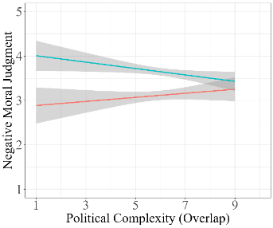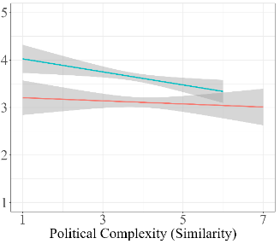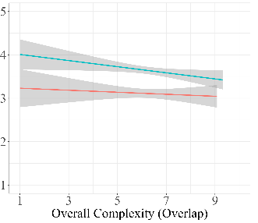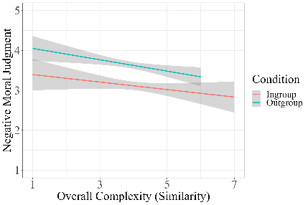
Study 2 (Democrats)
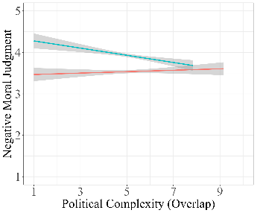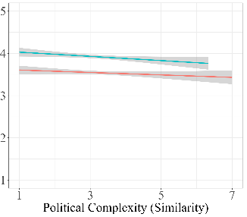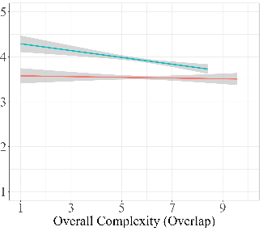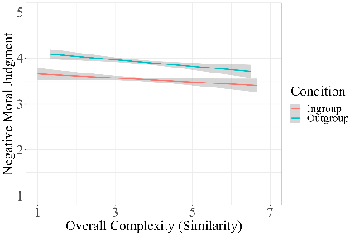
Study 2 (Republicans)
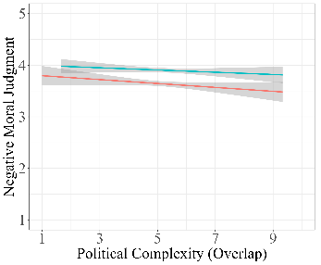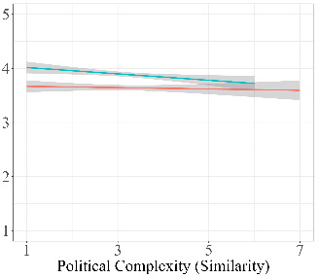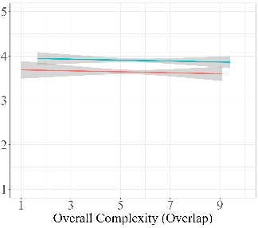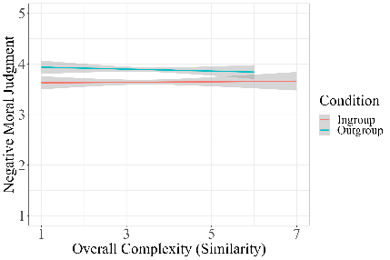
Study 3 (Ingroup Derogation Scenarios)
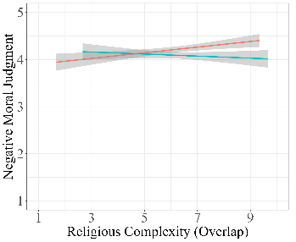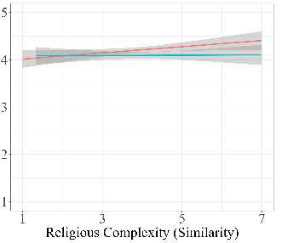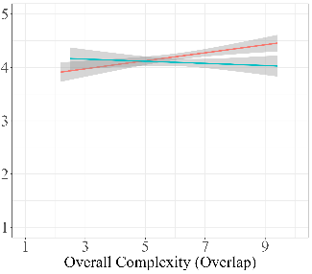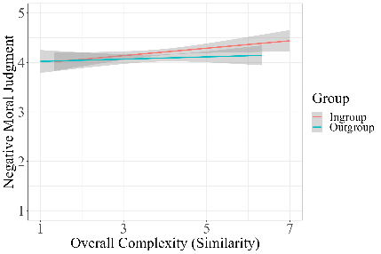
Study 3 (Outgroup Derogation Senario)
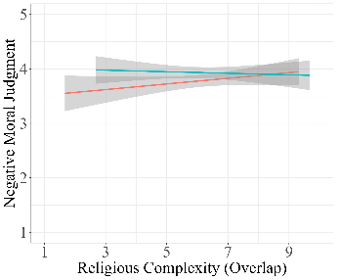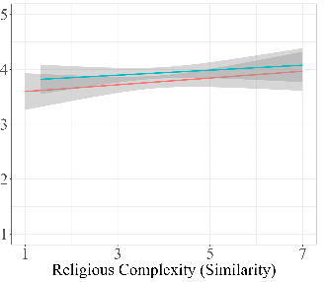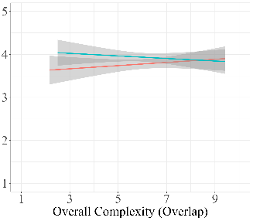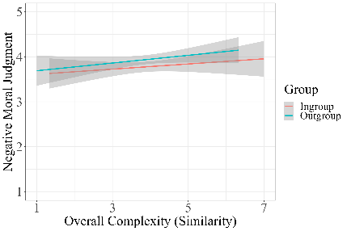
Perceived Typicality of Transgressors
There was a main effect of group in all models such that participants perceived outgroup transgressors to be more typical group members than ingroup transgressors. There was also a main effect of political complexity (o) such that greater political complexity (o) was associated with perceiving transgressors as less typical group members. Simple slopes analyses showed that the effect of political complexity (o) was similarly strong for perceptions of ingroup (β = -0.12, p = .020) and outgroup (β = -0.12, p = .040) transgressors. While the effect of political complexity (s) was trending in the same direction, the main effect was marginally significant (β = -0.08, p = .049). Simple slopes analyses revealed that the effect of political complexity (s) was not significant in either condition (ingroup: β = -0.08, p = .094; outgroup = β = -0.09, p = .129).
The effect of overall complexity (o) was similarly strong as that of political complexity (o) on perceptions of ingroup (β = -0.12, p = .024) and outgroup (β = -0.11, p = .057) transgressors; however, the latter was marginal. The effect of overall complexity (s) was stronger than that of political complexity (s) on perceptions of ingroup transgressors (β = -0.11, p = .021), but weaker than that of political complexity (s) on outgroup transgressors (β = -0.06, p = .345). Thus, while they varied in strength, all measures of SIC were associated with perceiving both ingroup and outgroup transgressors as less typical.

Figure. 3
Identity Complexity is Associated with Perceiving Transgressors as Less Typical
Study 1
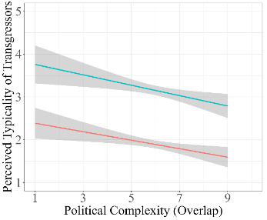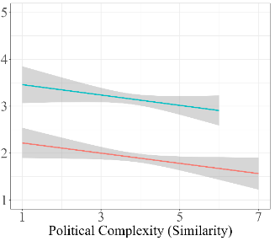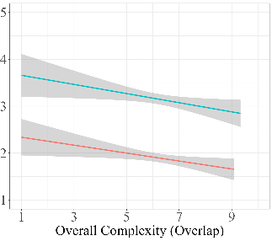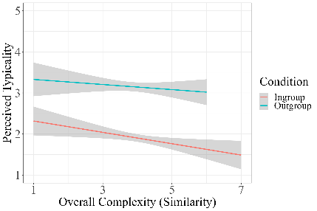
Study 2 (Democrats)
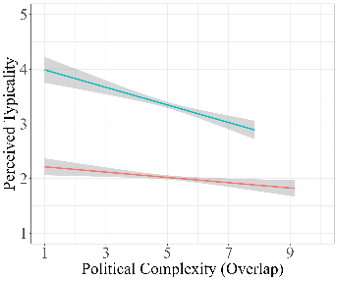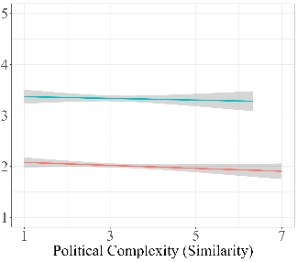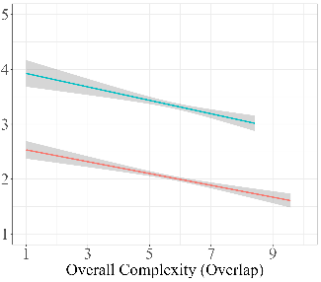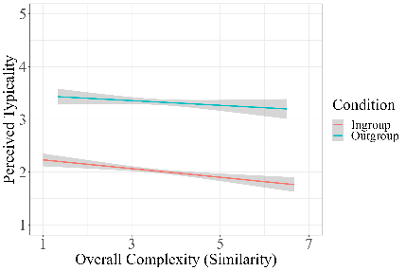
Study 2 (Republicans)
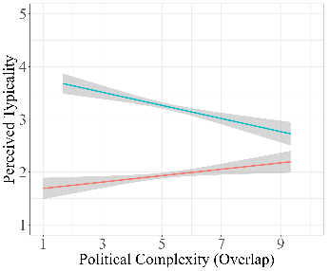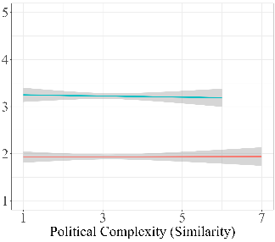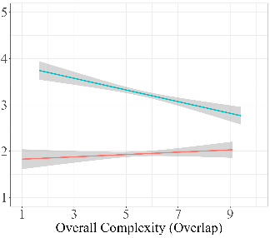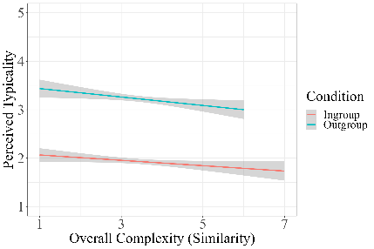
Study 3 (Ingroup Derogation Scenarios)
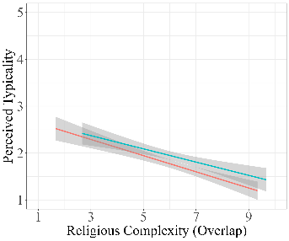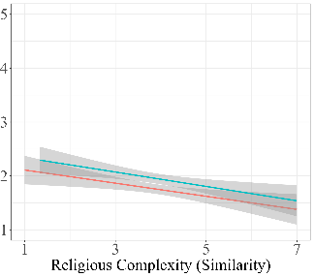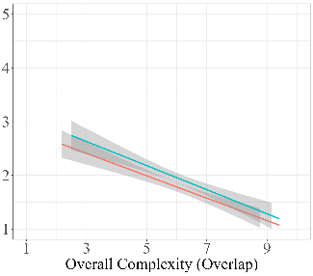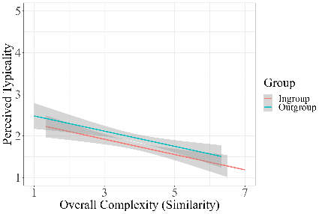
Study 4 (Outgroup Derogation Scenario)
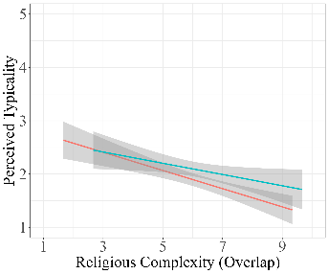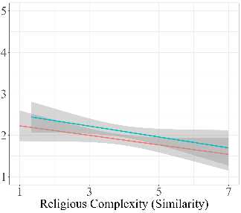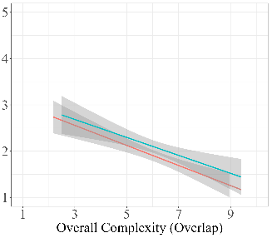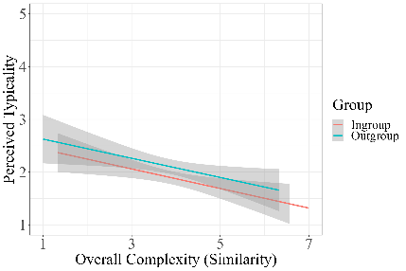
Perceived Typicality and Moral Judgment
To test whether perceiving transgressors as more typical exacerbates intergroup bias in moral judgments, we examined the interaction between perceived typicality and group on negative moral judgments. We found a significant interaction such that greater perceived typicality was associated with greater mean differences in negative moral judgment of ingroup and outgroup transgressors. That is, there were larger gaps in mean judgments of ingroup and outgroup transgressors when transgressors were perceived to be more typical. Specifically, perceiving transgressors as more typical group members was associated with more negative judgments of outgroup transgressors (β = 0.16, p < .001) and less negative judgments of ingroup transgressors (β = -0.27, p < .001).
To examine a potential pathway through which SIC may impact moral judgment, we conducted a causal mediation analysis using the "mediation” and “MASS” packages in R for each group (ingroup and outgroup) in which we examined the indirect effect of SIC through perceived typicality on moral judgment. We found a significant indirect effect of political complexity (o) on judgments of both the ingroup (β = 0.03, p = .001) and outgroup (β = -0.02, p = .002). We also observed indirect effects for the other three measures of SIC on judgments of the ingroup, but only overlap complexity (o) also had a significant indirect effect on judgments of the outgroup. These results suggest that perceiving transgressors as more typical group members may drive the influence of group biases (i.e., outgroup derogation, ingroup favoritism) on moral judgments of their actions. People high in SIC perceive transgressors as less typical, in turn reducing biased judgments of their actions.

Figure. 4
Perceived Typicality Moderates Impact of Group on Negative Moral Judgment
Study 1
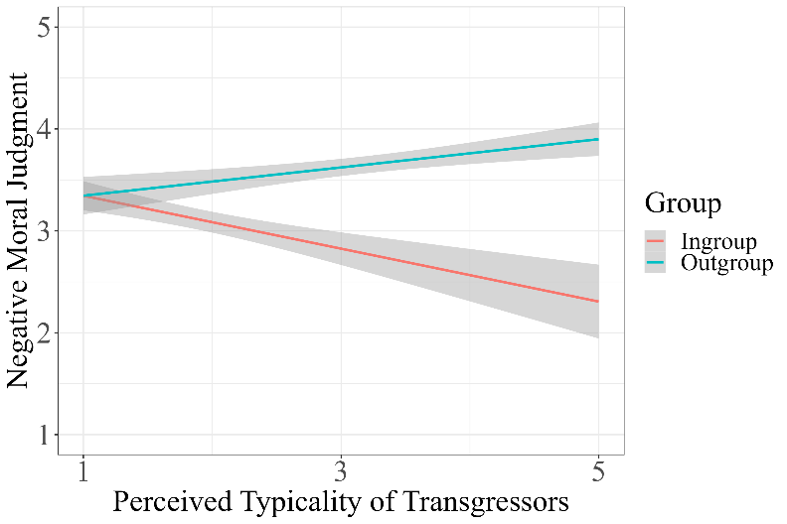
Study 2 (Democrats) Study 2 (Republicans)
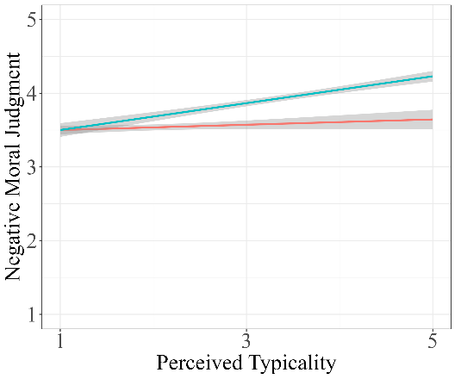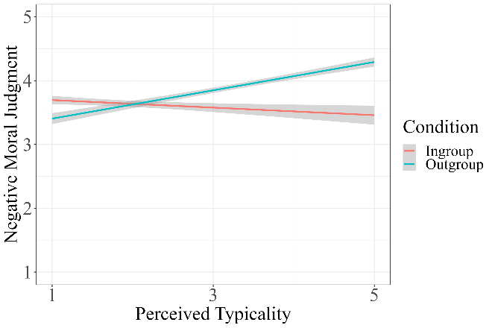
Study 3 (Ingroup Derogation Scenarios) Study 3 (Outgroup Derogation Scenario)
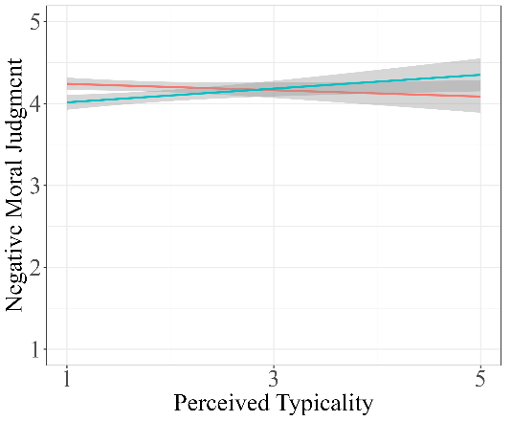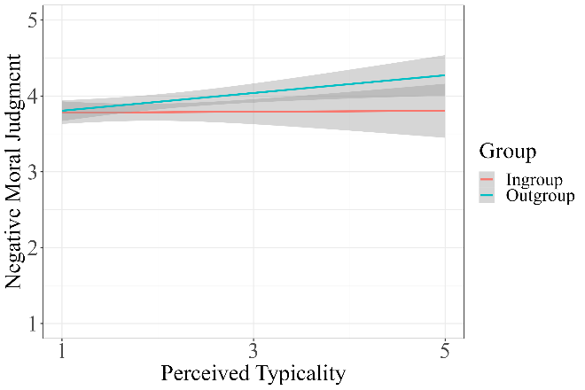

Study 1 Summary
In Study 1, we expanded upon prior work investigating the impact of SIC on evaluations of ingroup transgressors in a campus riot scenario (Costabile & Austin, 2021) by investigating the impact of SIC on moral judgments of both ingroup and outgroup transgressors in a campus riot scenario in a controlled, experimental setting. Study 1 provides evidence that social identity complexity may mitigate intergroup bias in moral judgments. This effect appeared to be driven in part by both reduced outgroup derogation, as people high in SIC judged outgroup transgressors less harshly, and reduced ingroup favoritism, as people high in SIC judged ingroup transgressors more harshly. We also found that people high in SIC tend to perceive transgressors as less typical group members and that, in turn, perceiving transgressors as less typical is associated with judging outgroup transgressors less harshly and ingroup transgressors more harshly. Perceived typicality significantly mediated the effect of SIC on moral judgment. Finally, we observed that the effects of political complexity (o) appeared to be the most robust compared to the other three measures of SIC, suggesting that the complexity of the salient identity, specifically the overlap between the salient identity and one’s other identities, may play a stronger role in judgments and perceptions of transgressors than overall identity complexity. In Study 2, we aimed to replicate these effects across a broader range of scenarios and examine the impact of political party.
Study 2
In Study 2, we aimed to replicate the results of Study 1 across six transgression scenarios. We also aimed to explore potential differences between Democrats and Republicans. In order to compare the effects based on party, we preselected participants who identified as Democrat or Republican.
Participants
Participants were American adults recruited and compensated via Prolific. We used G*Power to determine the number of participants required to have 80% power to detect an effect size of d = 0.2 for a two-tailed independent t-test with alpha of .05. Results showed that N = 394 participants are required per group, so we aimed to sample N = 394 participants for each of the two conditions (ingroup versus outgroup). We oversampled 665 in the ingroup condition and 541 in the outgroup condition, including 673 Democrats and 533 Republicans (Table 1).
Procedure
Study 2 followed the same design as Study 1, however each participant responded to all six vignettes, displayed in a random order. We selected transgressions that represented a variety of domains and, to reduce participant response bias, were in some way tied to political affiliation. Transgressions included the campus riot scenario from Study 1 in addition to biased grading of students’ work, damaging a protest sign, publishing misinformation, abusing political power, and stealing from charity.
Measures
Participants completed the same measures as Study 1 in addition to two exploratory measures, openness to intergroup contact and loss of respect for ingroup and outgroup members. Items and results for these exploratory measures are reported in the Supplementary Materials.
Results
To examine the impact of social identity complexity and group on our outcomes across vignettes, we fitted a series of linear mixed-effects models using the package “lme” with vignette and participant id entered as random intercepts and controlling for age, gender, political identity strength, race, religion, and socioeconomic status. We report the results for Democrats and Republicans separately.
Moral Judgment of Transgressors
As in Study 1, there was a main effect of group in all models such that participants judged outgroup transgressors more negatively than ingroup transgressors. Replicating the results of Study 1, we again found a significant interaction between political complexity (o) and group such that political complexity (o) was associated with smaller mean differences in moral judgment of ingroup and outgroup transgressors. However, we only observed this interaction among Democrats. Political complexity (o) was associated with less negative judgments of outgroup transgressors among Democrats (β = -.09, p = .017) but was not associated with judgments of outgroup transgressors among Republicans (β = -0.01, p = .747) or with judgments of ingroup transgressors among either Democrats (β < 0.01, p = .939) or Republicans (β = -0.04, p = .382). As in Study 1, there was no significant interaction between political complexity (s) and group. Political complexity (s) was associated with less negative judgments of outgroup transgressors among Democrats (β = -.07, p = .066) and Republicans (β = -0.07, p = .047), yet the former was marginal. As in Study 1, political complexity (s) was not significantly associated with judgments of ingroup transgressors among Democrats (β < 0.01, p = .797) or Republicans (β < 0.01, p = .936).
The effect of overall complexity (o) on judgments of outgroup transgressors was similar to that of political complexity (o) among Democrats (β = -0.10, p = .007) and Republicans (β < -0.01, p = .932). The effect of overall complexity (o) on judgments of ingroup transgressors was similarly small as that of political complexity (o) among both Democrats (β < -0.01, p = .962) and Republicans (β = -0.01, p = .777). The effect of overall complexity (s) on judgments of outgroup transgressors was stronger than that of political complexity (s) among Democrats (β = -0.10, p = .008) but weaker than that among Republicans (β = -0.05, p = .194). The effect of overall complexity (s) on judgments of ingroup transgressors was similar to that of political complexity (s) among Democrats (β < .807, p = .003) and Republicans (β = 0.01, p = .802). Thus, we found that SIC was associated with reduced outgroup derogation in moral judgments among Democrats, but was not associated with reduced ingroup favoritism and was not linked to moral judgment among Republicans.
Perceived Typicality of Transgressors
As in Study 1, there was a main effect of group in all models such that participants perceived outgroup transgressors to be more typical group members than ingroup transgressors. As in Study 1, greater political complexity (o) tended to be associated with perceiving transgressors as less typical, however this effect was observed only among Democrats. Simple slopes analyses showed that political complexity (o) was associated with perceiving both outgroup (β = -0.14, p = .007) and ingroup (β = -0.06, p = .043) transgressors as less typical group members among Democrats, but the effects were stronger for perceptions of outgroup transgressors. Political complexity (o) was associated with perceiving outgroup (β = -0.09, p = .069) transgressors as less typical among Republicans, but the effects were marginal. Although the results in Figure 2. suggest that SIC may be associated with perceiving ingroup members as more typical among Republicans, after controlling for age, gender, and political identity strength, political complexity (o) was not associated with perceptions of the typicality of ingroup transgressors among Republicans (β = 0.01, p = .760). As in Study 1, there was no significant main effect of political complexity (s). Simple slopes analyses showed that political complexity (s) was not significantly associated with outgroup (Democrats: β = -0.03, p = .513, Republicans: β = -0.03, p = .544) or ingroup (Democrats: β = -0.03, p = .390, Republicans: β = -0.02, p = .653) transgressors.
The effect of overall complexity (o) on perceptions of outgroup transgressors was similar to that of political complexity (o) among Democrats (β = -0.14, p = .004) and Republicans (β = -0.10, p = .028). The effect of overall complexity (o) on perceptions on ingroup transgressors was stronger than that of political complexity (o) among Democrats (β = -0.11, p < .001) but similarly weak among Republicans (β = -0.01, p = .830). The effect of overall complexity (s) on perceptions of ingroup transgressors were similar weak as that of political complexity (s) among Democrats (β = -0.05, p = .111) and Republicans (β = -0.05 p = .178). The effect of overall complexity (s) on perceptions of outgroup transgressors was larger than that of political complexity (s) among Democrats (β = -0.07, p = .150) and Republicans (β = -0.07, p = .121), but still not significant. Thus, we observed that the effect of overall complexity (o) on perceptions appeared to be the most robust and was associated with perceiving outgroup transgressors as less typical among both parties, and perceiving ingroup transgressors as less typical among Democrats, but not Republicans.
Perceived Typicality and Moral Judgment
Replicating the results of Study 1, we found a significant interaction effect between perceived typicality and group on negative moral judgment such that greater perceived typicality was associated with greater mean differences in negative moral judgment of ingroup and outgroup transgressors. We observed this effect for both Democrats and Republicans. As in Study 1, perceiving transgressors as more typical group members was associated with more negative judgments of outgroup transgressors (Democrats: β = 0.18, p < .001, Republicans: β = 0.18, p < .001) and less negative judgments of ingroup transgressors (Democrats: β = -.05, p = .041, Republicans: β = -0.08, p = .012). In contrast to Study 1, the effects were stronger for perceptions of outgroup transgressors.
As in Study 1, we found a significant indirect effect of political complexity (o) via perceived typicality on moral judgment in the outgroup condition among both Democrats (β = -.03, p < .001) and Republicans (β = -0.03, p < .001). Among both Democrats and Republicans, we also observed indirect effects on moral judgments of the outgroup for overall complexity (o) and overall complexity (s), but not political complexity (s). As in Study 1, there was a significant indirect effect of political complexity (o) in the ingroup condition, however this effect was only significant among Republicans (Democrats: β = -0.002, p = .080, Republicans: β < -0.003, p = .030). Among Democrats, there were no significant indirect effects in the ingroup condition for any measure of SIC, which makes sense given that SIC did not have a significant effect on moral judgments of the ingroup. Among Republicans, overall complexity (s) also had a significant indirect effect in the ingroup condition, but political complexity (s) and overall complexity (o) did not.
Study 2 Summary
In Study 2, we aimed to replicate the results of Study 1 across a variety of transgression scenarios. As in Study 1, we found that SIC was associated with judging outgroup members less harshly, but, unlike Study 1, was not associated with judgments of ingroup members, suggesting that in a political context, SIC may have a stronger impact on outgroup derogation than ingroup favoritism. Existing work on SIC has focused largely on its impact on attitudes toward the outgroup rather than the ingroup (e.g., Schmid et al., 2014); thus, more work is needed to better understand how SIC may impact judgments of ingroup members. As in Study 1, we found that SIC was associated with perceiving ingroup and outgroup transgressors as less typical and that perceiving transgressors as less typical mediated the impact of SIC on judgments of outgroup transgressors. In this study, we observed that the effects of SIC on moral judgments and perceptions of typicality are different for Democrats and Republicans. SIC was not directly associated with moral judgments among Republicans and was not associated with perceptions of the typicality of ingroup transgressors among Republicans. In both parties, we observed a significant indirect effect of SIC on moral judgments of the outgroup via perceived typicality. These results suggest that perceptions of how prototypical group members are may play a more direct role in Republicans’ moral judgments than perceptions of the relationships between their own social groups. Future research is necessary to unpack party differences in how these mechanisms may interact for moral judgment. Additionally, in this study we did not observe that political complexity had consistently more robust effects than overall complexity. Yet, we did find evidence that the effects of overlap complexity are stronger than the effects of similarity complexity. Some prior work has found that overlap complexity can have a stronger impact on bias than similarity complexity (Roccas & Brewer, 2002), but most studies examining SIC exclude the measure of similarity complexity (e.g., Schmid et al., 2009; Costabile & Austin, 2018; Roccas et al., 2022), so it is unclear what might be driving these different effects. It could be that this measure of similarity complexity may evoke comparisons of stereotypical information rather than participants’ own perceptions of the similarity between groups. Future work is needed to tease apart these differences.
In Studies 1-2, we used a limited measure of identity strength that may not have accurately captured how strongly participants identity with their social groups. Prior theoretical work suggests that people high in SIC are likely to have greater self-concept flexibility (Brewer, 2010). Having less rigid attachments to one’s identities and weaker connections between one’s identities may lead people high in SIC to have reduced identity strength. Thus, it is possible that the effects of SIC on evaluations of moral transgressors may be reduced after directly controlling for identity strength. To test this hypothesis, we evaluated and controlled for identity strength using a more direct measure of identity strength in Study 3. Further, we aimed to further demonstrate the robustness of the effects of beyond a political intergroup context by examining them in a religious context in Study 3.
Study 3
In Study 3, we aimed to replicate the results of Studies 1-2 in a religious context and test whether the effects of SIC hold controlling for the effects of identity strength using a more direct measure of identity strength. Study 3 followed the same design as Study 2 but examined how people judged members of their own and other groups based on religion (Christians versus Jews).
Participants
As preregistered, we aimed to recruit N = 200 participants per condition (ingroup versus outgroup), but given the limited number of Jewish participants on online recruitment platforms, we expected to recruit fewer than 200 Jewish participants. We recruited participants from Prolific and recruited additional Jewish participants from Cloud Research. We oversampled 264 participants in the ingroup condition and 274 in the outgroup condition, including 343 Christian participants and 195 Jewish participants (Table 1). A sensitivity analysis conducted using the package “pwr” showed that this sample size provided 80% power to detect an R-squared of 0.02 or greater for a regression model with 3 predictors, with an alpha of 0.05.
Procedure
Participants followed the same procedure as Study 2. Transgressions for Study 3 included four adapted from Study 2 (i.e., riot, biased grading, stealing from charity, publishing misinformation), and two novel transgressions (i.e., vandalizing other local religious buildings, online bullying). In all scenarios, the transgression was in some way tied to or driven by religious affiliation (e.g., religious charity, biased grading or bullying those who do not share one’s religious beliefs, etc.) to reduce participant response bias. Half of participants were randomly assigned to read that the transgressions were committed by religious ingroup members (ingroup condition), and the other half were randomly assigned to read that the transgressions were committed by religious outgroup members (outgroup condition).
Measures
Participants completed the same measures as Study 2, excluding the two exploratory items (i.e., loss of respect and openness to intergroup contact). Participants in Study 3 also completed an identity strength measure:
Identity Strength
Participants indicated how strongly they identify with each of their four social groups on a 5-point Likert scale (1 = “Not very strongly”; 5 = “Extremely strongly”).
Results
Similar to Studies 1-2, we examined the impact of both overall complexity and the complexity of the salient identity, which in this study was religion. Religious complexity was computed using the same approach for calculating political complexity in Studies 1-2. Religious identity strength had a small negative correlation with religious complexity (o) (r = -0.12, p < .001) and religious complexity (s) (r = -0.19, p < .001). Similar to Study 2, we analyzed our main results by fitting a series of linear mixed-effects models using the package “lme” with vignette and participant id entered as random intercepts. We controlled for age, gender, religion (dummy coded as 0 = Christian, 1 = Jewish), religiosity, race, political party, SES, and religious identity strength in all models.
Moral Judgment of Transgressors
Although we did not expect the effect of group to differ in Study 3, we observed that differences in moral judgments of ingroup and outgroup transgressors diverged across scenarios. In the biased grading scenario and the campus riot scenario, participants tended to judge outgroup transgressors more harshly than ingroup transgressors, but this difference was significant only in the biased grading scenario. In the stealing from charity, vandalizing religious buildings, online bullying, and publishing misinformation scenarios, participants tended to judge ingroup transgressors more harshly than outgroup transgressors; however, this difference was significant only in the stealing and vandalizing scenarios. Prior work suggests that judging ingroup members more harshly than outgroup members, known as the Black Sheep Effect, can occur to maintain social cohesion when the transgression threatens the group (Tang et al., 2023) or when those transgressions are harmless (Bettache et al., 2018). However, the victims in all the scenarios used in the current work were interpersonal (i.e., ingroup harming the outgroup, outgroup harming the ingroup), so there was a clear interpersonal harm posed by each transgression. In addition, since all ingroup transgressions were directed at the outgroup, there was no direct threat to the ingroup posed by ingroup transgressors. Yet, it is possible that participants may have felt like these transgressions could threaten the positive reputation of the ingroup. Since we observed the Black Sheep effect for Study 3 but not Studies 1-2, this could indicate that potential reputational threats are more important for religious identity than political identity. As a result of the diverging impact of group across scenarios, there was no main overall effect of group on negative moral judgments of religious ingroup (M = 3.85, SD = 0.90) and outgroup (M = 3.82, SD = 0.89) transgressors. Given these diverging results, we analyzed the results separately for the two scenarios in which participants displayed significant bias against ingroup members (ingroup derogation scenarios) and the scenario in which participants displayed significant bias against outgroup members (outgroup derogation scenario). For the latter, we used multiple linear regression. Results across all scenarios are reported in the Supplementary Materials.
Ingroup Derogation Scenarios. There was a main effect of religious complexity (o) on moral judgment in the ingroup derogation scenarios such that greater religious complexity (o) was associated with judging transgressors more harshly. There was also a significant interaction between religious complexity (o) and condition such that the effect on judgments of ingroup members was stronger than the effect on judgments of outgroup members. Replicating the effects of Studies 1-2, greater religious complexity (o) was associated with more negative judgments of ingroup transgressors (β = 0.14, p < .001) and less negative judgments of outgroup transgressors (β = -0.06, p = .202), but the latter was not significant. There was no main effect or interaction effect of religious complexity (s). Religious complexity (s) was not significantly associated with judgments of the outgroup (β < 0.01, p = .952) or the ingroup (β = 0.06, p = .177). The effect of overall complexity (o) was similar to that of religious complexity (o) for judgments of the outgroup (β = -0.04, p = .424) and the ingroup (β = 0.13, p < .001). The effect of overall complexity (s) was similar to religious complexity (s) for judgments of the outgroup (β < 0.01, p = .941) and the ingroup (β = 0.06, p = .132). Thus, we observed that, in scenarios in which participants tended to judge ingroup members more harshly than outgroup members, overlap complexity was associated with judging ingroup members more harshly, but not judgments of outgroup members.
Outgroup Derogation Scenario. There was no main effect of religious complexity (o) or interaction between religious complexity (o) and condition in the outgroup derogation scenario. Follow-up analyses showed that the religious complexity (o) tended to be associated with more negative judgments of ingroup (β = 0.06, p = .321) and less negative judgments of outgroup (β = -0.07, p = .248) transgressors, but these effects were not significant. There was no main effect or interaction effect of religious complexity (s). Religious complexity (s) was not significantly associated with judgments of ingroup (β = -0.02, p = .722) or outgroup (β = 0.04, p = .452). The effect of overall complexity (o) was similar to that of religious complexity (o) for judgments of the ingroup (β = 0.04, p = .456) and the outgroup (β = -0.07, p = .239). The effect of overall complexity (s) was similar to that of religious complexity (s) for judgments of the ingroup (β = -0.02, p = .716) and the outgroup (β = 0.07, p = .163). Thus, in the scenario in which participants tended to judge outgroup members more harshly than ingroup members, we observed no significant effect of SIC on moral judgment.
Perceived Typicality of Transgressors
Similar to Studies 1-2, there was a marginal main effect of group in all models such that participants tended to perceive outgroup transgressors as more typical group members than ingroup transgressors. Replicating the effects of Studies 1-2, there was a significant main effect of religious complexity (o) in both ingroup derogation and outgroup derogation scenarios such that greater religious complexity (o) was associated with perceiving transgressors as less typical group members. Simple slopes analyses showed that the effect of religious complexity (o) was slightly stronger for perceptions of the outgroup (ingroup derogation scenarios: β = -0.30, p < .001, outgroup derogation scenario: β = -0.31, p < .001) than perceptions of the ingroup (ingroup derogation scenarios: β = -0.22, p < .001, outgroup derogation scenarios: β = -0.19, p < .001). We observed similar but weaker effects for religious complexity (s). Religious complexity (s) was associated with perceiving both outgroup (ingroup derogation scenarios: β = -0.14, p = .016, outgroup derogation scenarios: β = -0.18, p = .007) and ingroup (ingroup derogation scenarios: β = -0.13, p = .011, outgroup derogation scenarios: β = -0.05, p = .329) transgressors as less typical, however the latter was not significant for the outgroup derogation scenario. Overall complexity (o) had a similar effect as religious complexity (s) for judgments of the outgroup (ingroup derogation scenarios: β = -0.33, p < .001, outgroup derogation scenarios: β = -0.33, p < .001) and the ingroup (ingroup derogation scenarios: β = -0.23, p < .001, outgroup derogation scenarios: β = -0.23, p < .001). Overall complexity (s) had a similar effect as religious complexity (s) for judgments of the outgroup (ingroup derogation scenarios: β = -0.14, p = .021, outgroup derogation scenarios: β = -0.18, p = .004) but slightly stronger for judgments of the ingroup (ingroup derogation scenarios: β = -0.18, p < .001, outgroup derogation scenarios: β = -0.10, p = .070. Thus, we observed that, across both types of scenarios, SIC was associated with perceiving transgressors as less typical group members.

Moral Judgment and Perceived Typicality
Unlike Studies 1-2, we found that there was no significant interaction between perceived typicality and group on negative moral judgments, yet the simple effects trended in the same direction. Perceived typicality was associated with more negative judgments of outgroup transgressors (ingroup derogation scenarios: β = 0.07, p = .073, outgroup derogation scenarios: β = 0.11, p = .034), although the former was marginal, and less negative judgments of ingroup transgressors (ingroup derogation scenarios: β = -0.03, p = .437, outgroup derogation scenarios: β = -0.01, p = .829), but the effects were small and not significant. Thus, in contrast to Studies 1-2, we observed that perceiving transgressors as more typical was not consistently associated with moral judgments. This could have been due to a floor effect for perceptions of typicality, as the mean and median for perceived typicality were quite low in both types of scenarios (ingroup derogation scenarios: Mean = 1.86, SD = 1.10, Median = 1.00, outgroup derogation scenarios: Mean = 1.99, SD = 1.11, Median = 2.00). Unlike in Studies 1-2, there were no significant indirect effects of SIC on moral judgment via perceived typicality in either type of scenario, which is likely due to the fact that perceived typicality was not significantly associated with moral judgments in this study.
Study 3 Summary
In Study 3, we examined the impact of social identity complexity on responses to moral transgressions committed by ingroup and outgroup transgressors in a religious context, controlling for religious identity strength. We observed two different patterns of bias: in some scenarios, participants judged outgroup members more harshly than ingroup members; in others, they judged ingroup members more harshly, a pattern known as the Black Sheep Effect. Although we did not expect to observe Black Sheep effects in Study 3, this allowed us to examine how SIC would moderate bias against ingroup members. In Black Sheep Effect scenarios, we found that, replicating the results of Studies 1 and 2, SIC was associated with more negative judgments of ingroup members and less negative judgments of outgroup members, but the latter was not significant. These results demonstrate the robustness of the association between SIC and reduced ingroup favoritism, suggesting that SIC may even contribute to a greater Black Sheep effect in situations in which ingroup transgressors were judged more harshly than outgroup transgressors. We did not observe a direct effect of SIC on moral judgment in the outgroup derogation scenario. Future work is needed to clarify whether this may have been due to domain-specific or scenario-specific differences. Replicating the results of Studies 1-2, we found that, in both types of scenarios, SIC was associated with perceiving transgressors as less typical group members, whether they were ingroup or outgroup members. Yet, contrary to Studies 1-2, perceived typicality was not significantly associated with moral judgments, which may have been due to the unexpected finding that perceptions of typicality were largely at floor. It is unclear why we observed this floor effect for Study 3; it is possible that transgressors are more likely to be perceived as atypical in a religious context compared to a political context, but more work is needed to clarify this. Overall, Study 3 demonstrated that the effects of SIC on judgments of ingroup members and perceptions of the typicality of ingroup and outgroup transgressors are robust controlling for identity strength and may sometimes exacerbate the Black Sheep effect.
General Discussion
This work demonstrates that the extent to which people display intergroup bias in social cognition depends on the relationships between their multiple social identities. Across three studies (N = 2,484), we show that greater social identity complexity (SIC), perceiving one’s groups as having low levels of overlap and similarity, is associated with reduced outgroup derogation and ingroup favoritism across a variety of transgressions in political and religious contexts. This work integrates and advances research in the spaces of moral judgment and social identity in several key ways.
Abundant empirical work focuses on the factors that influence moral judgment, such as values (e.g., Levine & Schweitzer, 2014), principles (e.g., Conway & Gawronski, 2013), and perceived intentions (e.g., Rowe et al., 2021), as well as those that influence intergroup bias, such as motivated reasoning (Hughes & Zaki, 2015; Kunda, 1990) and collective self-esteem (Crocker & Luhtanene, 1990). In the present work, we aimed to examine intergroup bias in the context of moral judgments. Our results underscore the importance of considering multiple identities, rather than focusing solely on a primary or salient identity (e.g., political affiliation or religion), when examining moral judgments. This aligns with the evolving literature on social identity complexity, which suggests that people with greater social identity complexity may be less characterized by outgroup prejudice. The current project extends this work by demonstrating that SIC may also buffer against intergroup biases in the domain of moral judgment. Specifically, SIC is associated with judging outgroup transgressors less harshly and ingroup transgressors more harshly. In scenarios in which people tended to display intergroup bias against outgroup members, greater SIC was linked to a reduced gap in judgment of ingroup and outgroup members. In scenarios in which people tended to display the Black Sheep effect, judging ingroup members more harshly than outgroup members, greater SIC was linked to an exacerbated effect, judging ingroup members even more harshly. These results highlight SIC as a potential buffer against intergroup bias in moral judgment and highlight the robustness of the impact of SIC on judgments of ingroup members, which may exacerbate the Black Sheep effect. Future work can leverage SIC as a potential target for interventions that seek to reduce intergroup bias in moral judgments.
Additionally, the present work advances theoretic and empirical work on the impact of SIC on social cognition by identifying a key mechanism through which SIC may influence perception. Across studies, SIC was linked to perceiving moral transgressors as less typical members of their social groups, suggesting that people high in SIC tend to view social deviants as less stereotypical and may be less likely to generalize the actions of a few to the whole group. In Studies 1-2, perceiving transgressors as less typical was in turn linked to reduced intergroup bias in moral judgments, suggesting that perceptions of the typicality of transgressors may drive the effects of SIC on judgments. SIC is likely associated with viewing any individual group member as less prototypical, which may be due to perceptions of groups as more heterogenous. Future work can clarify how perceptions of diversity within groups broadly may impact moral judgments.
The present work was limited in several ways. Since the current data on SIC is cross-sectional, we are unable to infer causality from the observed relationships between SIC, moral judgment, and the perceived typicality of moral transgressors. Future work should use experimental studies in which the salience or strength of SIC is manipulated to investigate these links. Moreover, the current measure of SIC was limited in that it assessed the relationships between only political identity, religious identity, racial identity, and a fourth identity of their choice. While this approach is advantageous in that it allowed us to examine the complexity among identities that have important implications for intergroup moral judgments, it may have been unable to capture the complexity of other identities, such as among occupation and gender or education and immigration status. To address this, future studies could allow participants to choose all four of the identities included in the measure. Finally, the vignettes we used in this study were limited in that they focused only on intergroup harms in political and religious contexts. The effects of SIC on moral judgment could be different in other contexts, such as race or gender, or when the victim is a member of the transgressor’s group. Further exploring how the effects of SIC may vary across different types of transgressions may also help clarify why the effects of SIC were stronger for judgments and perceptions of the outgroup in some cases (Study 2) but stronger for judgments and perceptions of the ingroup in others (Study 3).
Conclusion
When individuals embrace membership in cross-cutting or counterstereotypic social groups, they tend to view people less as simple extensions of their social groups and more as individuals. Focusing on individual characteristics, they are less likely to express harmful intergroup biases, such as outgroup derogation and ingroup favoritism, when forming judgments of individuals’ actions. In this way, promoting engagement with groups often portrayed as conflicting or incompatible may help buffer against prejudice, fostering fairer and more nuanced responses to wrongdoings.
Open Practices
Pre-registrations for Studies 2 and 3 can be found here: Study 2: https://doi.org/10.17605/OSF.IO/36ZSA; Study 3: https://doi.org/10.17605/OSF.IO/82DFZ. Both preregistrations included the hypotheses, methods, and analysis plan. All materials, data, and analysis scripts are publicly available: https://osf.io/xj3ed/?view_only=9c2a368c35064eb69502fa56fed415de.

Acknowledgments
Author note: This work was supported by the John Templeton Foundation and the National Science Foundation Graduate Research Fellowship.

References
Abrams, D., Randsley de Moura, G., & Travaglino, G. A. (2013). A double standard when group members behave badly: Transgression credit to ingroup leaders. Journal of Personality and Social Psychology, 105(5), 799–815. https://doi.org/10.1037/a0033600
Bettache, K., Hamamura, T., Amrani Idrissi, J., Amenyogbo, R. G. J., & Chiu, C. (2019). Monitoring Moral Virtue: When the Moral Transgressions of In-Group Members Are Judged More Severely. Journal of Cross-Cultural Psychology, 50(2), 268–284. https://doi.org/10.1177/0022022118814687
Bocian, K., Cichocka, A., & Wojciszke, B. (2021). Moral tribalism: Moral judgments of actions supporting ingroup interests depend on collective narcissism. Journal of Experimental Social Psychology, 93, 104098. https://doi.org/10.1016/j.jesp.2020.104098
Brewer, M. B. (2010). Social Identity Complexity and Acceptance of Diversity. In R. J. Crisp (Ed.), The Psychology of Social and Cultural Diversity (pp. 9–33). Wiley-Blackwell. https://doi.org/10.1002/9781444325447.ch2
Chekroun, P., & Nugier, A. (2011). “I’m ashamed because of you, so please, don’t do that!”: Reactions to deviance as a protection against a threat to social image. European Journal of Social Psychology, 41(4), 479–488. https://doi.org/10.1002/ejsp.809
Costabile, K. A., & Austin, A. B. (2018). A riot on campus: The effects of social identity complexity on emotions and reparative attitudes after ingroup-perpetrated violence. Aggressive Behavior, 44(1), 50–59. https://doi.org/10.1002/ab.21723
Crawford, M. T., Sherman, S. J., & Hamilton, D. L. (2002). Perceived entitativity, stereotype formation, and the interchangeability of group members. Journal of Personality and Social Psychology, 83(5), 1076–1094. https://doi.org/10.1037/0022-3514.83.5.1076
Conway, P., & Gawronski, B. (2013). Deontological and utilitarian inclinations in moral decision making: A process dissociation approach. Journal of Personality and Social Psychology, 104(2), 216–235. https://doi.org/10.1037/a0031021
Crocker, J., & Luhtanen, R. (1990). Collective self-esteem and ingroup bias. Journal of Personality and Social Psychology, 58(1), 60–67. https://doi.org/10.1037/0022-3514.58.1.60
Derreumaux, Y., Elder, J., Suri, G., Ben-Zeev, A., Quimby, T., & Hughes, B. L. (2023). Stereotypes disrupt probabilistic category learning. Journal of Experimental Psychology: General, 152(6), 1622–1638. https://doi.org/10.1037/xge0001335
Gresky, D. M., Eyck, L. L. T., Lord, C. G., & McIntyre, R. B. (2005). Effects of Salient Multiple Identities on Women’s Performance Under Mathematics Stereotype Threat. Sex Roles, 53(9–10), 703–716. https://doi.org/10.1007/s11199-005-7735-2
Hewstone, M., & Lord, C. G. (1997). Changing Intergroup Cognitions and Intergroup Behavior. In C. Sedikides (Ed.), Intergroup cognition and intergroup behavior (1st ed.). Psychology Press.
Hughes, B. L., & Zaki, J. (2015). The neuroscience of motivated cognition. Trends in Cognitive Sciences, 19(2), 62–64. https://doi.org/10.1016/j.tics.2014.12.006
Knifsend, C. A., & Juvonen, J. (2014). Social Identity Complexity, Cross-Ethnic Friendships, and Intergroup Attitudes in Urban Middle Schools. Child Development, 85 (2), 709–721. https://doi.org/10.1111/cdev.12157
Kunda, Z. (1990). The case for motivated reasoning. Psychological Bulletin, 108(3), 480–498. https://doi.org/10.1037/0033-2909.108.3.480
Kunda, Z., & Oleson, K. C. (1995). Maintaining stereotypes in the face of disconfirmation: Constructing grounds for subtyping deviants. Journal of Personality and Social Psychology, 68(4), 565–579. https://doi.org/10.1037/0022-3514.68.4.565
Lambert, A. J., & Wyer, R. S. (1990). Stereotypes and social judgment: The effects of typicality and group heterogeneity. Journal of Personality and Social Psychology, 59(4), 676–691. https://doi.org/10.1037/0022-3514.59.4.676
Levine, E. E., & Schweitzer, M. E. (2014). Are liars ethical? On the tension between benevolence and honesty. Journal of Experimental Social Psychology, 53, 107–117. https://doi.org/10.1016/j.jesp.2014.03.005
Lickel, B., Hamilton, D. L., Wieczorkowska, G., Lewis, A., Sherman, S. J., & Uhles, A. N. (2000). Varieties of groups and the perception of group entitativity. Journal of Personality and Social Psychology, 78(2), 223–246. https://doi.org/10.1037/0022-3514.78.2.223
Linville, P. W., & Fischer, G. W. (1993). Exemplar and Abstraction Models of Perceived Group Variability and Stereotypicality. Social Cognition, 11(1), 92–125. https://doi.org/10.1521/soco.1993.11.1.92
Lord, C. G., Desforges, D. M., Ramsey, S. L., Trezza, G. R., & Lepper, M. R. (1991). Typicality effects in attitude-behavior consistency: Effects of category discrimination and category knowledge. Journal of Experimental Social Psychology, 27(6), 550–575. https://doi.org/10.1016/0022-1031(91)90025-2
Meeussen, L., Phalet, K., Meeus, J., Van Acker, K., Montreuil, A., & Bourhis, R. (2013). “They are all the same”: Low perceived typicality and outgroup disapproval as buffers of intergroup threat in mass media. International Journal of Intercultural Relations, 37(2), 146–158. https://doi.org/10.1016/j.ijintrel.2012.05.002
Miller, K. P., Brewer, M. B., & Arbuckle, N. L. (2009). Social Identity Complexity: Its Correlates and Antecedents. Group Processes & Intergroup Relations, 12(1), 79–94. https://doi.org/10.1177/1368430208098778
Miller, K. P., Brewer, M. B., & Arbuckle, N. L. (2009). Social Identity Complexity: Its Correlates and Antecedents. Group Processes & Intergroup Relations,12(1), 79–94. https://doi.org/10.1177/1368430208098778
Richards, Z., & Hewstone, M. (2001). Subtyping and Subgrouping: Processes for the Prevention and Promotion of Stereotype Change. Personality and Social Psychology Review, 5(1), 52–73. https://doi.org/10.1207/S15327957PSPR0501_4
Roccas, S., & Brewer, M. B. (2002). Social Identity Complexity. Personality and Social Psychology Review, 6(2), 88–106. https://doi.org/10.1207/S15327957PSPR0602_01
Roccas, S., Amit, A., Oppenheim-Weller, S., Hazan, O., & Sagiv, L. (2022). Inclusive and exclusive beneficiary attributions: The role of social identity complexity in interpretations of and punishment for dissent. Group Processes & Intergroup Relations, 25(6), 1653–1671. https://doi.org/10.1177/13684302211019479
Rowe, S. J., Vonasch, A. J., & Turp, M.-J. (2021). Unjustifiably Irresponsible: The Effects of Social Roles on Attributions of Intent. Social Psychological and Personality Science, 12(8), 1446–1456. https://doi.org/10.1177/1948550620971086
Schmid, K., Hewstone, M., Tausch, N., Cairns, E., & Hughes, J. (2009). Antecedents and Consequences of Social Identity Complexity: Intergroup Contact, Distinctiveness Threat, and Outgroup Attitudes. Personality and Social Psychology Bulletin, 35(8), 1085–1098. https://doi.org/10.1177/0146167209337037
Schiller, B., Baumgartner, T., & Knoch, D. (2014). Intergroup bias in third-party punishment stems from both ingroup favoritism and outgroup discrimination. Evolution and Human Behavior, 35(3), 169–175. https://doi.org/10.1016/j.evolhumbehav.2013.12.006
Tang, S., Shepherd, S., & Kay, A. C. (2023). Morality’s role in the Black Sheep Effect: When and why ingroup members are judged more harshly than outgroup members for the same transgression. European Journal of Social Psychology, 53(7), 1605–1622. https://doi.org/10.1002/ejsp.3001
Valdesolo, P., & DeSteno, D. (2008). The duality of virtue: Deconstructing the moral hypocrite. Journal of Experimental Social Psychology, 44(5), 1334–1338. https://doi.org/10.1016/j.jesp.2008.03.010
Van Der Toorn, J., Ellemers, N., & Doosje, B. (2015). The threat of moral transgression: The impact of group membership and moral opportunity. European Journal of Social Psychology, 45(5), 609–622. https://doi.org/10.1002/ejsp.2119
Yudkin, D. A., Rothmund, T., Twardawski, M., Thalla, N., & Van Bavel, J. J. (2016). Reflexive intergroup bias in third-party punishment. Journal of Experimental Psychology: General, 145(11), 1448–1459. https://doi.org/10.1037/xge0000190

