Abstract
In a dilemma, who is more commendable: the agent who chooses a more virtuous action after overcoming temptation toward a less virtuous one, or the agent who chooses the same virtuous action without experiencing temptation? Certain studies in the literature have shown evidence supporting both conflicting answers to this question. Others have shown that the answer may depend on whether the dilemma is morally valenced or not. In the current work, we unify and extend the literature for a more complete psychological account of the relationship between temptation and virtue. Study 1 shows that, in moral dilemmas, giving into temptation is a much more influential factor in moral judgement than experiencing temptation. Studies 2 and 3 show that, in non-moral dilemmas, agents who overcome temptation are rated better than untempted agents. This effect is unchanged regardless of whether agents are adults or children, but is diminished when untempted agents lack intentionality in choosing virtuous actions. Study 4 uses a within-subjects design to replicate the effect from Studies 2 and 3 and show that, in moral dilemmas, untempted agents are rated better than agents who overcome temptation. However, the effect in moral dilemmas is more robust than the effect in non-moral dilemmas. Study 4 also links individual preference for the untempted to endorsement of a growth mindset in the moral domain.
Keywords. temptation, virtue, morality, effort, growth mindset

1. Introduction
In their daily life, people face the choice of whether to act more or less virtuously: whether to donate to a charity, purchase a more ethically sourced product, give up their seat on the train, take time to help an acquaintance, and so on. Some of these decisions come with ease, but, for others, people will experience temptation to choose the (often easier) less virtuous option and will need to overcome this temptation to act virtuously. Are these acts more or less virtuous than they would be if the person never experiences temptation in the first place? Moral philosophy offers insight into the link between inner conflict and morality, both in general (Knobe & Nichols, 2011; Nahmias et al., 2007) and in the context of temptation. Some argue that the most virtuous actions are those accomplished with ease (Aristotle, 2019; Taylor & Gaita, 1981), while others posit that effort put into an action (e.g., to overcome temptation) elevates its virtuosity (Halfon, 1989; Kant et al., 2002). Empirical research has approached this question in a few sets of studies, showing that lay perceptions can align with either philosophical perspective, depending on the situation (Berman & Small, 2018; McManus et al., 2024; Starmans & Bloom, 2016). However, the literature to date still leaves some open questions surrounding the relationship between temptation and virtue. In particular, the role of the behavior that is chosen (i.e., how are agents who overcome temptation evaluated relative to agents who give into it?), the agent’s age (i.e., are tempted children seen differently than tempted adults?) and the agent’s intentionality (i.e., does it matter why the agents make their decisions?) are not well understood. Here, we extend previous work by leveraging a broader manipulation of temptation that includes both agents who overcome and give into temptation. Furthermore, we contribute depth to the literature by examining the role of agent characteristics and by providing nuance to established effects.
Previous work on temptation and virtue has produced a variety of results, some of which are inconsistent with one another. In one classic set of studies, Starmans & Bloom (2016) showed participants vignettes featuring two child agents faced with a dilemma between a good action and a bad action. For example, one dilemma involved the agents having to choose between keeping a promise they made to clean up their toys and going outside to play with their friends. While both agents always chose the good action (e.g., cleaning up their toys), one of them had to overcome their temptation to choose the bad action (e.g., playing outside instead), while the other never experienced this temptation in the first place. When asked which of the agents was “more good,” participants were on average more likely to choose the agent who overcame temptation. In contrast, more recent work by McManus et al. (2024) uncovered the opposite pattern of moral judgments. The researchers showed participants two adult agents faced with a dilemma, one of whom chose the good action through overcoming temptation toward the bad action, and the other of whom chose the good action without experiencing any temptation in the first place. For example, one scenario involved agents deciding whether to return a lost wallet or keep the money inside it. When asked to rate which agent was more virtuous, participants tended to make the opposite choice from Starmans & Bloom (2016): they chose the agent who experienced no temptation at all.
One possible explanation for the conflicting results in these two sets of studies is the work of Berman & Small (2018). These researchers also instructed participants to compare agents who overcame temptation to agents who never experienced it, but they simultaneously manipulated their scenarios to be moral or non-moral. In moral scenarios, tempted agents were tempted toward behaviors that are immoral (e.g., stealing). In non-moral scenarios, tempted agents were tempted toward morally neutral behaviors that were only made bad in context (e.g., eating pizza after having promised oneself to go to the gym). Berman & Small (2018) found that participants rated the tempted agent as more virtuous in non-moral scenarios, but the untempted agent more virtuous in moral scenarios. As the researchers explain, participants focused on the willpower signaled by overcoming temptation in non-moral scenarios, but on the purity signaled by never experiencing temptation in moral scenarios. Notably, both Starmans & Bloom (2016) and McManus et al. (2024) framed their scenarios as involving “immoral” temptation (i.e., considered their scenarios to be moral). Therefore, we cannot confidently attribute the discrepancy between their findings to the moral versus non-moral scenario distinction.
In the literature surrounding temptation and virtue to date, the main comparison of interest has been between agents who choose good behaviors with versus without needing to overcome temptation to do so. However, there is another aspect of the relationship between temptation and virtue unexplained by current literature that we believe needs investigation. Specifically, it is yet to be examined how the perceived virtuosity of these agents compares to that of agents who fail to overcome temptation (i.e., who choose bad behaviors instead of good ones). Thus, the relative strength of the effect of temptation versus the effect of which behavior is chosen is not well understood. For example, to the extent that experiencing temptation does decrease perceived virtuosity, does it account for a small portion or a large majority of the decrease associated with choosing a bad action? Simultaneously comparing the virtuosity of tempted versus untempted agents and agents who choose good versus bad behaviors will help create a more complete picture of the influence of temptation on perceptions of virtue.
Beyond this investigation, we believe it is of theoretical interest to provide a complete explanation for the discrepancy between the findings of Starmans & Bloom (2016) and McManus et al. (2024). There are three key differences between the paradigms used in these two papers that we believe may account for their opposite effects. First, Starmans & Bloom (2016) used child agents in their scenarios, while McManus et al. (2024) used adult agents. It is possible that participants have different expectations about the behavior of children and adults, leading to different reactions about agents who experience temptation. Specifically, participants may see children as still developing their moral decision making skills and expect them to struggle with choosing good actions. Thus, participants might choose to praise child agents who are tempted by bad actions, rewarding them for the extra effort it takes to practice their skills and overcome their temptation. In contrast, participants may expect adults to have good decision making skills already, meaning that they would withhold praise from agents who experienced temptation toward bad behaviors. This would account for participants’ tendency to say that the child agent who overcame temptation was better in Starmans & Bloom (2016) but that the adult agent who did not experience temptation was better in McManus et al. (2024).
Second, Starmans & Bloom (2016) and McManus et al. (2024) manipulated temptation in different ways, likely affecting the perceived intentionality of their agents’ decisions. When describing agents who did not experience temptation, Starmans & Bloom (2016) not only stated that agents did not desire to do the bad action in the present moment, but also stated that they generally disliked the bad action. For example, one scenario stated, “Emma does not want to go play with her friends right now. She doesn’t like playing outside, and wants to clean up her toys.” In contrast, McManus et al. (2024) gave no explicit information about whether untempted agents generally liked or disliked the bad actions. For example, one scenario said, “Kenna does not feel conflicted about this decision. She does not want to steal the cash that is inside the wallet, and she is not tempted to do so.” To illustrate the difference between these two manipulations, if McManus et al. (2024) had manipulated temptation in the same way that Starmans & Bloom (2016) did, that scenario might have said, “Kenna does not feel conflicted about this decision. She doesn’t like using cash. She does not want to steal the cash that is inside the wallet, and she is not tempted to do so.” Since the manipulation used by Starmans & Bloom (2016) involves information about the stable attitudes of the agents, we will refer to it as a trait manipulation of temptation. Similarly, we will refer to the manipulation from McManus et al. (2024) as a non-trait manipulation of temptation. These different manipulations may produce different effects of temptation due to the perceived intentionality of the untempted agent. Specifically, under a trait manipulation of temptation, participants may see an untempted agent’s decision to do the good action as lacking intention, and therefore lacking meaning: since the agent explicitly dislikes the bad action, they would never engage in it anyway, simply choosing the good action by default. Thus, participants may rate the tempted agent as better, since they were intentional in choosing a good action over a bad one. In contrast, under a non-trait manipulation, participants may still assume that untempted agents would like to do the bad action, meaning that neither agent makes a decision without intention. Then, participants may reward untempted agents for making their decision more easily than tempted agents (Critcher et al., 2013).
Third, we believe that Starmans & Bloom (2016) and McManus et al. (2024) used different kinds of scenarios. Specifically, though the authors of both papers described their agents as having “immoral” temptations, we argue that the scenarios used in McManus et al. (2024) are moral scenarios, while those used in Starmans & Bloom (2016) are non-moral. Given that Berman & Small (2018) found that the type of scenario reverses the effect of temptation on virtuosity, we believe it is likely that this difference contributed to the opposite effects found in the two papers.
Beyond these theoretical interests, we aim to contribute to the methodological rigor of the literature on this topic. Recent work has shown that standard group-level statistical tests, and the reports that go alongside them, are frequently not representative of a majority of individual participants in a study (McManus et al., 2023). In other words, when researchers write, “Ratings were higher in condition X than in condition Y,” they may only be describing a small minority of participants in the study. To ensure the robustness of our findings, we will report person-level descriptive statistics in addition to group-level inferential statistics for our main findings.
In the studies that follow, we aim to develop a unified psychological account of the effect of temptation on perceptions of virtuosity. In Study 1, we show that which behavior is chosen is a much more influential factor in determining judgements of morality than the experience of temptation. In Study 2, we conceptually replicate Starmans & Bloom (2016) and show that the effect of temptation does not change with the agent’s age. In Study 3, we show that the effect of temptation does change with temptation manipulation type: a non-trait manipulation reduces the extent to which tempted agents are rated as more praiseworthy than untempted agents. However, this is not enough to reverse the effect of Starmans & Bloom (2016). In Study 4, we conceptually replicate Berman & Small (2018), showing that the effect of temptation does change with scenario type. Participants rate tempted agents as more praiseworthy in non-moral scenarios, but untempted agents as more praiseworthy in moral scenarios.

2. Study 1
Previous work has shown that most participants judge agents who overcome temptation toward an immoral behavior as morally worse than agents who never experience temptation in the first place. However, prior work has not tested how this effect of temptation compares to the effect of the actual behavior chosen by agents. In Study 1, we asked participants to rate the morality of agents who varied on two independent dimensions: whether they chose a good or bad behavior and whether they experienced or did not experience internal conflict about that decision (four different types of agents in total). Following results from related work in moral psychology (Critcher et al., 2013) and from our pilot work (see supplementary materials), we hypothesized that overall, agents who chose the good behavior would be rated as morally better than agents who chose the bad behavior. Further, following McManus et al. (2024), we hypothesized that agents who chose the good behavior without internal conflict (i.e., untempted agents) would be rated as morally better than agents who chose the good behavior with internal conflict (i.e., tempted agents). Finally, we hypothesized that agents who chose the bad behavior with internal conflict would be rated as morally better than agents who chose the bad behavior without internal conflict. This study was pre-registered at https://aspredicted.org/c6pn-t98k.pdf.

2.1. Methods

2.1.1. Participants
Participants were 150 US adults with a Prolific approval rating of at least 90. Per our pre-registered criteria, nine participants were excluded from analysis for either finishing the survey in less than half of the median time or answering the attention check question incorrectly. Thus, the final sample size was 141 (49% male, 49% female, 1% non-binary, 1% unknown, M_{age} = 35.60). The study lasted about 25 minutes and compensation for participation was $3.60.

2.1.2. Materials and Procedure
After consenting to the experiment, participants saw 16 scenarios in which an individual faced a moral dilemma. For example, one scenario described Mary, a woman who was deciding whether or not to smoke a cigarette at an asthmatic boy’s birthday party. The agents differed in both their thought processes and their ultimate decisions in the scenario. Specifically, agents could end up choosing either the good behavior (e.g., not smoking) or the bad behavior (e.g., smoking), and they could also be conflicted about this decision (e.g., “Mary feels very conflicted about this decision, and she gives it some thought.”) or not (e.g., “Mary does not feel very conflicted about this decision, and she does not give it any thought.”). Participants saw four scenarios with each agent type, and both the order of the scenarios and the assignment of scenarios to different agent types were counterbalanced. The 16 scenarios covered four different virtues: personal long-term vs. short term benefit, fairness, helping, and harm reduction.
After reading each scenario, participants were asked a battery of questions about the scenario and the two agents, summarized in Table 1.

Table 1
Dependent Variables of Study 1
Question |  | Lower Label | Upper Label | M | SD
For each agent
 | How moral was [agent] in this situation? | Very morally bad | Very morally good | 4.53 | 2.07
 | How much did the individual desire [outcome of the bad behavior]? | Not at all | Very much | 5.31 | 1.86
 | How much did the individual desire [outcome of the good behavior]? | Not at all | Very much | 4.27 | 2.26
 | How much was the individual tempted to [do the bad behavior]? | Not at all | Very much | 5.03 | 2.04
 | How much was the individual tempted to [do the good behavior]? | Not at all | Very much | 4.35 | 2.14
 | How much does the individual value [relevant virtue]? | Not at all | Very much | 4.46 | 2.23
 | How much control did the individual have over the thoughts they had in the situation? | No control | Complete control | 5.71 | 1.73
 | How much control did the individual have over the way they acted in the situation? | No control | Complete control | 6.14 | 1.52
 | If this were to happen again, how likely is it that the individual would act the same way in the future? | Not likely at all | Very likely | 5.77 | 1.33
 | How much time do you think the individual took to make their decision? | No time at all | A very long time | 3.06 | 1.83
For each scenario
 | How likely is it that the average person would be tempted to [do the bad behavior] in this situation? | Not likely at all | Very likely | 4.84 | 1.65
 | How high were the stakes of the decision that the individual had to make? | Very low | Very high | 5.01 | 1.78
Note. Responses to all questions were measured on 7-point Likert scales, with 1 being labeled using the “Lower Label” and 7 using the “Upper Label.” Italicized text was replaced with the corresponding language for the scenario.

2.2. Results
As pre-registered, we conducted a linear mixed effects model with conflict (dummy coded: 0 = conflicted, 1 = unconflicted) and behavior (dummy coded: 0 = good behavior, 1 = bad behavior) as the independent variables and moral goodness as the dependent variable.

Table 2
Results from the Linear Mixed Effects Model Predicting Morality Ratings from Conflict and Behavior
Effect | Estimate | SE | df | t | p
Conflict | 0.127 | 0.066 | 382.992 | 1.917 | .056
Behavior | -2.854 | 0.264 | 20.985 | -10.738 | < .001*
Conflict * Behavior | -0.300 | 0.095 | 387.388 | -2.978 | .003*
Note. * Indicates p < .05
The model showed no significant effect of conflict, but a significant effect of behavior, such that agents who chose the good behavior were rated as more morally good, and a significant interaction, such that the effect of behavior was stronger for unconflicted agents (see Table 2). Figure 1 shows ratings of moral goodness split by condition.

Figure 1
Moral Goodness Ratings by Condition
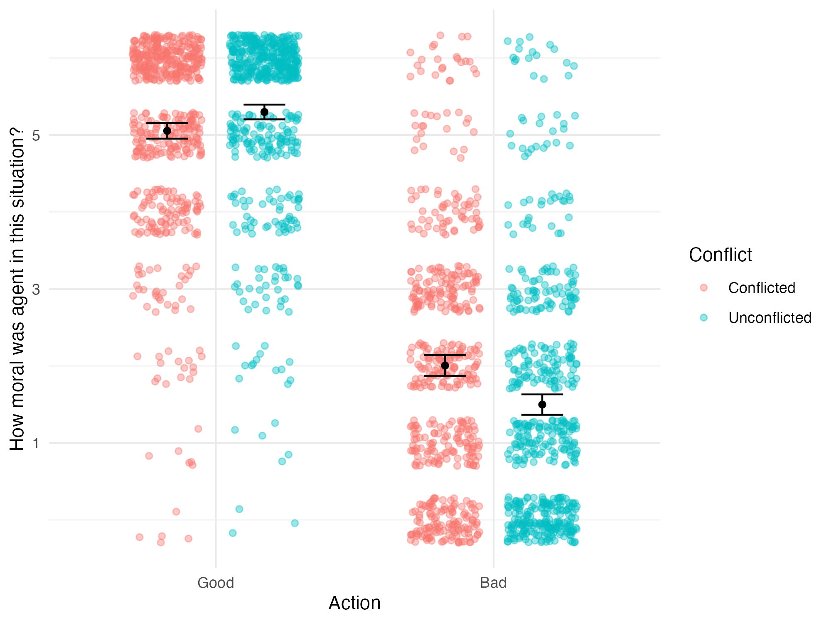
Note. Error bars represent 95% confidence intervals. One dot represents a single trial.

Follow up contrasts (not pre-registered) revealed that among agents who chose the good behavior, there was no effect of conflict (b = -0.127, SE = 0.066, t = -1.916, p = .056), but among agents who chose the bad behavior, there was an effect of conflict (b = 0.158, SE = 0.074, t = 2.129, p = .035) such that conflicted agents were rated as morally better on average.
To ensure the robustness of our findings, we also compiled person-level statistics for our principal effects of interest (McManus et al., 2023). We calculated the number of participants whose average morality judgements were greater, equal, and lesser for agents who choose the good behavior with versus without conflict (not pre-registered). We found that 48.9% of participants rated agents who chose the good behavior without conflict higher on average than agents who chose the good behavior with conflict. We also calculated the number of participants whose average morality judgements were greater, equal, and lesser for conflicted agents who chose the good versus bad behavior (not pre-registered). We found that 94.3% of participants rated conflicted agents who chose the good behavior as better than conflicted agents who chose the bad behavior on average. Table 3 shows the full results.

Table 3
Number of Participants with Each Effect between Unconflicted Good, Conflicted Good, and Conflicted Bad Agents
Comparison |  | N
Conflicted Good versus Unconflicted Good
 | Conflicted Good Agents More Moral | 41
 | Agents Equally Moral | 31
 | Unconflicted Good Agents More Moral | 69
Conflicted Bad versus Conflicted Good
 | Conflicted Bad Agents More Moral | 5
 | Agents Equally Moral | 3
 | Conflicted Good Agents More Moral | 133

To understand the structure of participants’ evaluations of the agents, we conducted exploratory factor analysis on the agent-specific dependent variables (pre-registered). Parallel analysis from the R package “psych” suggested that the number of factors was four. Thus, we conducted exploratory factor analysis for four factors with maximum likelihood extraction and oblique rotation. Factor loadings are presented in Table 4.

Table 4
Factor Loadings for the Agent-Specific Dependent Variables
Variable | Factor Loading
 | 1 | 2 | 3 | 4
Factor 1: Moral Goodness
Morality | 0.85 | -0.01 | 0.01 | -0.04
Good Temptation | 0.74 | -0.06 | 0 | 0.1
Good Outcome | 0.69 | -0.02 | -0.03 | 0.04
Value Virtue | 0.89 | -0.03 | 0 | 0.01
Factor 2: Moral Badness
Bad Temptation | -0.26 | 0.66 | -0.01 | 0.11
Bad Outcome | 0.02 | 0.82 | -0.02 | -0.03
Factor 3: Control
Control Thoughts | -0.05 | -0.04 | 1.01 | 0.03
Control Actions | 0.22 | 0.17 | 0.58 | -0.13
Factor 4: Unpredictability
Future | 0.14 | 0.17 | 0.12 | -0.5
Time | 0.13 | 0.1 | 0.04 | 0.7

3. Study 2
In Study 1, we showed that which behavior is chosen is a much more influential factor in determining judgements of morality than the presence or absence of temptation. However, we failed to replicate the finding from McManus et al. (2024) that tempted agents were rated as less virtuous than untempted agents. (Notably, the test of this effect was nearing significance, p = .056, and we do fully replicate this effect in Study 4 and Pilot Study 1. Thus, we are confident in the effect.) In Study 2, we aimed to replicate the finding from Starmans & Bloom (2016) that tempted agents were rated as more praiseworthy than untempted agents. We created a new set of stimuli closely inspired by theirs: non-moral scenarios involving child agents and a trait temptation manipulation. We hypothesized that participants would rate tempted agents as more praiseworthy than untempted agents.
In Study 2, we also aimed to isolate one of the differences between the papers—the age of the agent—and test whether it influenced the effect of temptation. Thus, unlike Starmans & Bloom, whose agents were exclusively children, we also manipulated whether the agents were children or adults. We hypothesized that this manipulation would invert the effect of temptation: participants would rate tempted agents as more praiseworthy when comparing two child agents, but tempted agents as less praiseworthy when comparing two adult agents. We predicted this reversal because we thought that participants might have different intuitions about the acceptability of adults and children experiencing temptation. Specifically, participants may expect child agents to struggle with making good decisions, meaning that they would not find child agents less praiseworthy on account of experiencing temptation. They would, however, still reward the effort that it takes to overcome that temptation. In contrast, participants may expect adult agents to make good decisions with ease, meaning that they would find adult agents less praiseworthy on account of experiencing temptation. This would overpower any inclination to reward the effort of overcoming temptation. This study was pre-registered at https://aspredicted.org/bnjc-rbb4.pdf.

3.1. Methods

3.1.1. Participants
Participants were 100 US adults. Per our pre-registered criteria, seven participants were excluded from analysis for either failing at least half of the trial-level manipulation checks or finishing the survey in less than half of the median time. Thus, the final sample size was 93 (47.31% male, 49.46% female, 1.08% non-binary, 2.15% unknown, M_{age} = 39.93). The study lasted about 8 minutes, and compensation for participation was $1.40.

3.1.2. Materials and Procedure
After consenting to the experiment, participants saw eight scenarios in which two characters each had to decide between two options in a dilemma. The dilemmas in these scenarios were designed to be non-moral, meaning that neither the good nor the bad behaviors were morally valenced. Furthermore, the “bad” behaviors were designed only to be bad in context. For example, one scenario described Mason and Ian, who could be tempted to watch football instead of doing work—neither of these is a morally valenced behavior, and watching football is only made bad by the agents needing to do work. In each scenario, one agent was always described as liking and wanting to do the bad behavior, while the other was described as disliking and not wanting to do the bad behavior. However, both agents always ended up choosing the good behavior. Additionally, we tested two versions of each scenario: one with child agents and one with adult agents. For example, in the child version, watching football would distract agents from completing a homework assignment; in the adult version, watching football would distract agents from writing a job application. All child agents were described as being in elementary school. Adults were described with a variety of indicators of their age, such as living with their spouse or working at a company. Participants saw four scenarios with adults and four with children; both the order of the scenarios and the assignment of agent age to scenarios were counterbalanced.
After reading each scenario, participants were asked questions about the agents and the scenario. For each scenario they were asked, “Which of the two people acted more morally in this situation?” (1 = [Agent 1] was much more moral, 7 = [Agent 2] was much more moral) and “How likely is it that the average person would be tempted to [do the bad behavior] in this situation?” (1 = Not likely at all, 7 = Very likely). They were also asked, “Which of the two agents was tempted to [do the bad behavior]?” (1 = [Agent 1], 2 = [Agent 2], 3 = Neither, 4 = Both) as a manipulation check. For each agent, they were asked, “How much moral praise does [agent] deserve for [doing the good behavior] in this situation?” (1 = No praise, 7 = Very much praise). All of these questions were novel to this study (i.e., were not asked by Starmans & Bloom), with the exception of the relative morality scale, which Starmans & Bloom asked in a binary format.

3.2. Results
As pre-registered, we conducted a linear mixed effects model with temptation (effect-coded: -0.5 = untempted, 0.5 = tempted) and agent age (effect-coded: -0.5 = child, 0.5 = adult) as the independent variables and moral praise as the dependent variable. The model showed a significant effect of temptation (b = 1.146, SE = 0.133, t = 8.615, p < .001), such that tempted agents were given more praise than untempted agents, a significant effect of agent age (b = -0.507, SE = 0.080, t = -6.337, p < .001), such that child agents were given more praise than adult agents, and no significant interaction (b = -0.038, SE = 0.124, t = -0.309, p = .768). Figure 2 shows moral praise ratings split by condition.

Figure 2
Moral Praise Ratings by Condition
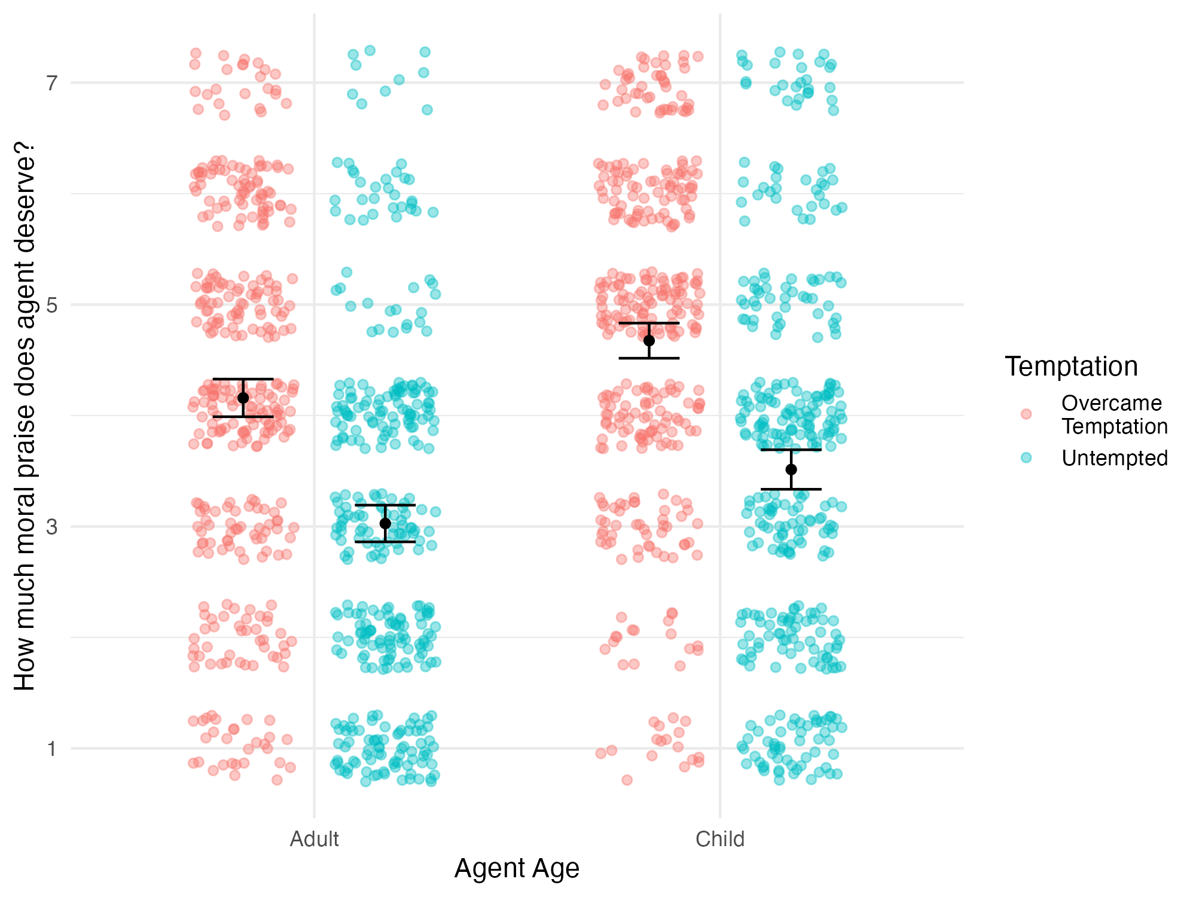
Note. Error bars represent 95% confidence intervals. One dot represents a single rating.

As pre-registered, we conducted a linear mixed effects model with agent age (effect-coded: -0.5 = child, 0.5 = adult) and average likelihood of temptation as the independent variables and relative morality as the dependent variable. The model showed no significant effect of agent age, no significant effect of average likelihood of temptation, and no significant interaction (|b|s < 0.060, SEs > 0.029, |t|s < 1.407, ps > 0.160). In addition, as pre-registered, we conducted two one-sample t-tests to assess whether relative morality differed from the neutral midpoint for both adult and child agents. The tests showed that participants rated the tempted agent as more moral for both adult agents, t(371) = 11.907, p < .001, and child agents, t(371) = 11.871, p < .001. Figure 3 shows relative morality responses by agent age.

Figure 3
Relative Morality Responses by Agent Age
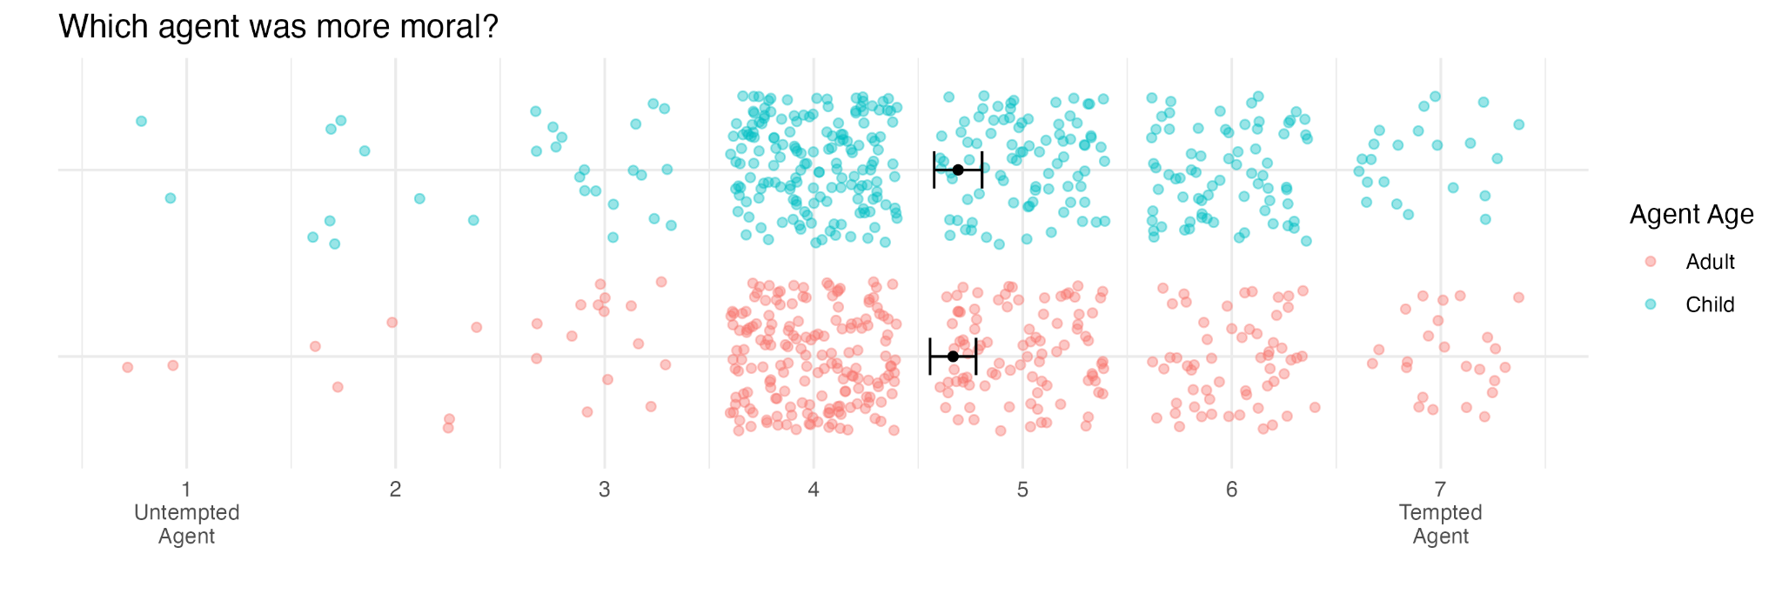
Note. Error bars represent 95% confidence intervals. One dot represents a single rating.

We calculated the number of participants whose average moral praise ratings were greater, equal, and lesser for agents who overcame versus did not experience temptation in both the adult and child conditions (not pre-registered). We found that 75.3% of participants rated agents who overcame temptation higher on average than agents who did not experience temptation in the adult condition, and 79.6% of participants did so in the child condition. Table 5 shows the full results.

Table 5
Number of Participants with Each Effect of Temptation for Adult and Child Agents
Effect Direction |  | N
Adult Condition
 | Untempted Agent More Praiseworthy | 5
 | Agents Equally Moral | 18
 | Tempted Agent More Praiseworthy | 70
Child Condition
 | Untempted Agent More Praiseworthy | 7
 | Agents Equally Moral | 12
 | Tempted Agent More Praiseworthy | 74

4. Study 3
In Study 2, we replicated the effect from Starmans & Bloom (2016): participants rated agents who overcame temptation (tempted agents) as more praiseworthy than agents who did not experience it in the first place (untempted agents). Furthermore, we found that this pattern did not change for scenarios involving adults, providing no evidence for our hypothesis that participants would find adults, but not children, less praiseworthy for experiencing temptation. In Study 3, we aimed to replicate this null effect of agent age and isolate another difference between the paradigms of Starmans & Bloom and McManus et al.: the use of trait versus non-trait temptation manipulations. In a trait manipulation of temptation, untempted agents are described not only as lacking temptation to do the bad behavior, but also as disliking the bad behavior in general, while tempted agents are described as liking and experiencing temptation to do the bad behavior. In a non-trait manipulation, agents are simply described as experiencing or not experiencing temptation, with no mention of whether they like the behavior or not. To assess the effect of these manipulations, we repeated the design of Study 2, but we varied whether a trait or non-trait temptation manipulation was used in each scenario.
We hypothesized that when a trait temptation manipulation is used, participants will rate tempted agents as more praiseworthy than untempted agents. For example, relative to a child who must overcome temptation to play outside in order to clean up their toys, a child who dislikes playing outside might receive little praise because they would clean up their toys by default. In contrast, we hypothesized that when a non-trait temptation manipulation is used, participants will rate tempted agents as less praiseworthy than untempted agents. For example, relative to a child who must overcome temptation, a child who likes playing outside but is still not tempted to do so might receive additional praise because of their ability to control their impulses. This study was pre-registered at https://aspredicted.org/fcts-sq9h.pdf.

4.1. Methods

4.1.1. Participants
Participants were 400 US adults. Per our pre-registered criteria, 72 participants were excluded from analysis for either failing at least half of the trial-level manipulation checks, finishing the survey in less than half of the median time, or failing the attention check. Thus, the final sample size was 328 (45.12% male, 50.61% female, 1.22% non-binary, 3.05% unknown, M_{age} = 39.81). The study lasted about 10 minutes, and compensation for participation was $1.40.

4.1.2. Materials and Procedure
After consenting to the experiment, participants saw the same eight scenarios from Study 2 with one key difference. In Study 2, one agent was always described as liking and wanting to do the bad behavior, while the other was described as disliking and not wanting to do the bad behavior (trait manipulation of temptation). In Study 3, on half of the trials, no information was given about whether agents liked or disliked doing the bad behavior: they were only described as wanting or not wanting to do it (non-trait manipulation of temptation). Otherwise, the studies were the same. Participants saw an equal number of scenarios with adults and children and an equal number of scenarios with each type of temptation manipulation. Both the order of the scenarios and the assignment of manipulation type and agent age to scenarios were counterbalanced. After half of the scenarios, there was an attention check question, which instructed participants to ignore the question wording beneath and select a specific answer instead.
After reading each scenario, participants were asked the exact same questions as they were in Study 2.

4.2. Results
As pre-registered, we conducted a linear mixed effects model with temptation (effect-coded: -0.5 = untempted, 0.5 = tempted), agent age (effect-coded: -0.5 = child, 0.5 = adult), and manipulation type (effect-coded: -0.5 = non-trait, 0.5 = trait) as the independent variables and moral praise as the dependent variable. The model showed a significant effect of temptation, such that tempted agents were praised more than untempted agents, a significant effect of agent age, such that children were praised more than adults, and a significant effect of manipulation type, such that agents in scenarios with a non-trait manipulation received more praise than agents in scenarios with a trait manipulation. Additionally, there was a significant interaction between temptation and manipulation type such that the effect of temptation was stronger under a trait manipulation than a non-trait manipulation. All other interaction effects were not significant (see Table 6). Figure 4 shows moral praise ratings split by temptation and manipulation type.

Figure 4
Moral Praise Ratings by Condition
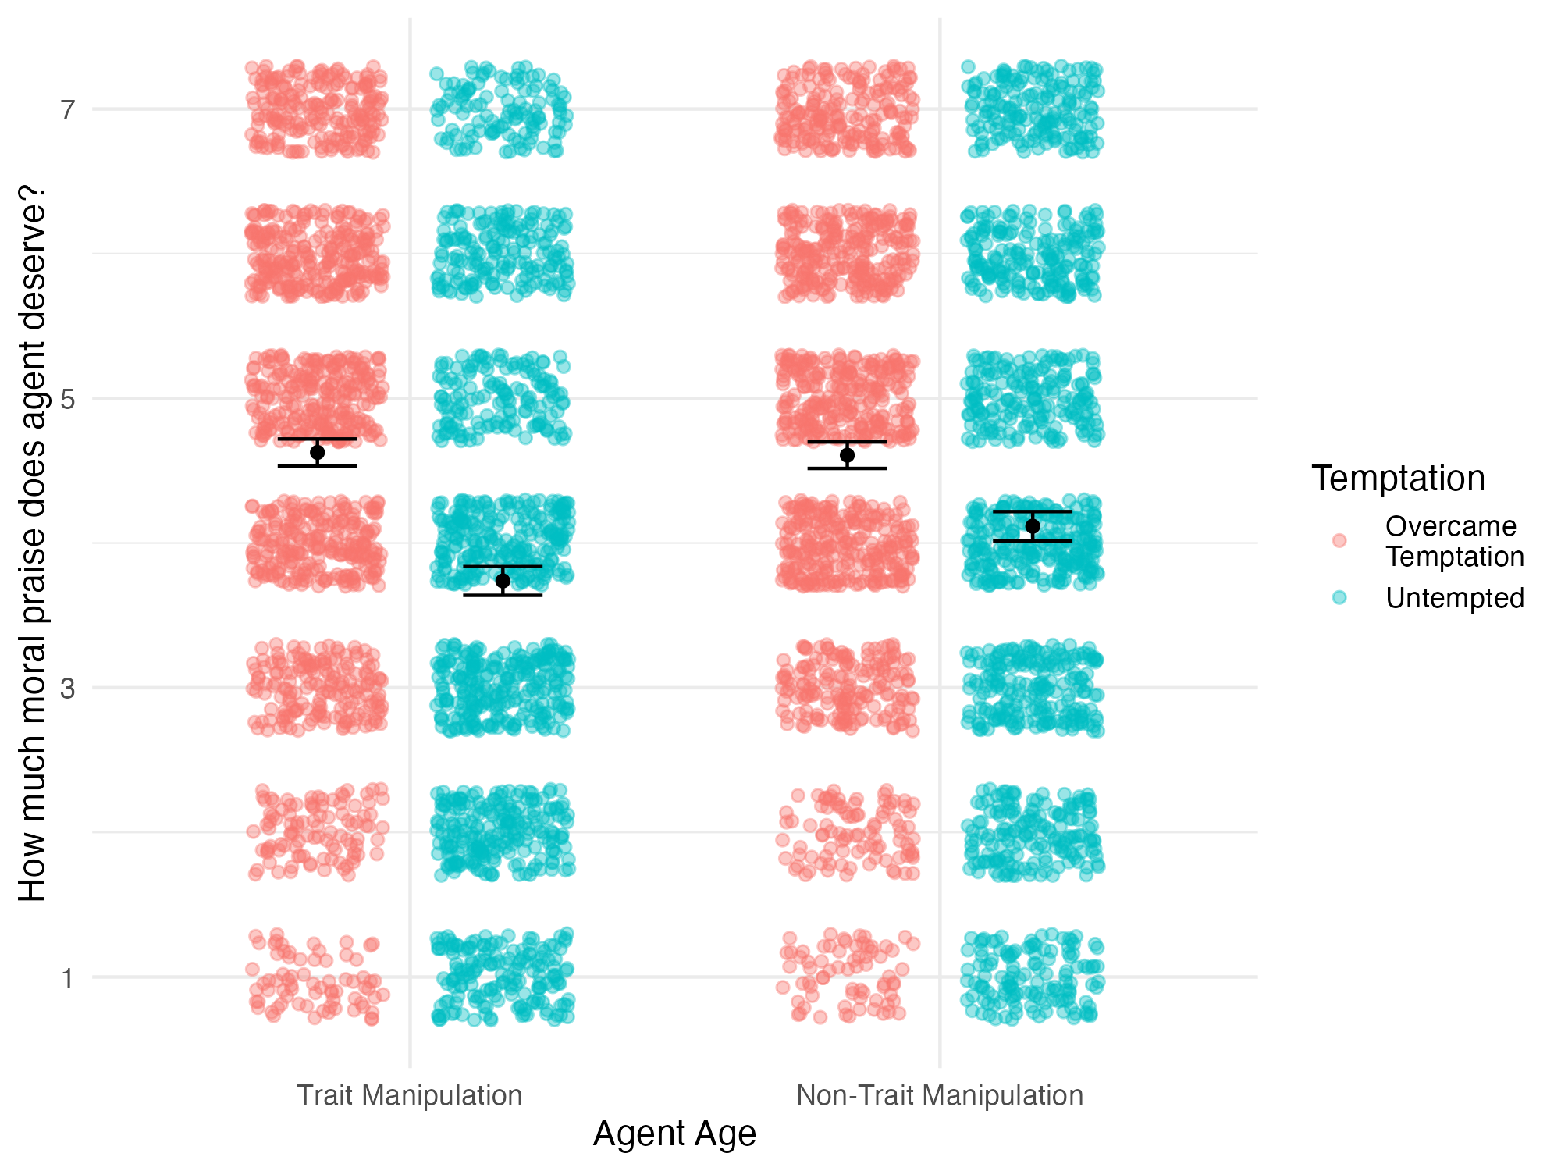
Note. Error bars represent 95% confidence intervals. One dot represents a single rating.

Table 6
Results of the Linear Mixed Effects Model Predicting Moral Praise from Temptation, Agent Age, and Manipulation Type
Effect | Estimate | SE | df | t | p
Temptation | 0.691 | 0.086 | 35.017 | 8.067 | < .001*
Agent Age | -0.321 | 0.07 | 9.383 | -4.611 | .001*
Manipulation Type | -0.166 | 0.038 | 9.1 | -4.416 | .002*
Temptation * Agent Age | -0.068 | 0.057 | 323.604 | -1.193 | .234
Temptation * Manipulation Type | 0.398 | 0.097 | 8.153 | 4.091 | .003*
Agent Age * Manipulation Type | 0.107 | 0.064 | 304.171 | 1.671 | .096*
Temptation * Agent Age * Manipulation Type | -0.073 | 0.116 | 3166.499 | -0.63 | .529
Note. * Indicates p < .05
As pre-registered, we also conducted a linear mixed effects model with agent age (effect-coded: -0.5 = child, 0.5 = adult), manipulation type (effect-coded: -0.5 = non-trait, 0.5 = trait), and average likelihood of temptation as the independent variables and relative morality as the dependent variable. There was a significant effect of manipulation type (b = 0.291, SE = 0.065, t = 4.488, p < .001) such that participants preferred the tempted agent more under a trait manipulation. All other effects were not significant (|b|s < 0.054, SEs > 0.017, |t|s < 1.424, ps > 0.064). Figure 5 shows relative morality responses split by condition.

Figure 5
Relative Morality Ratings by Condition
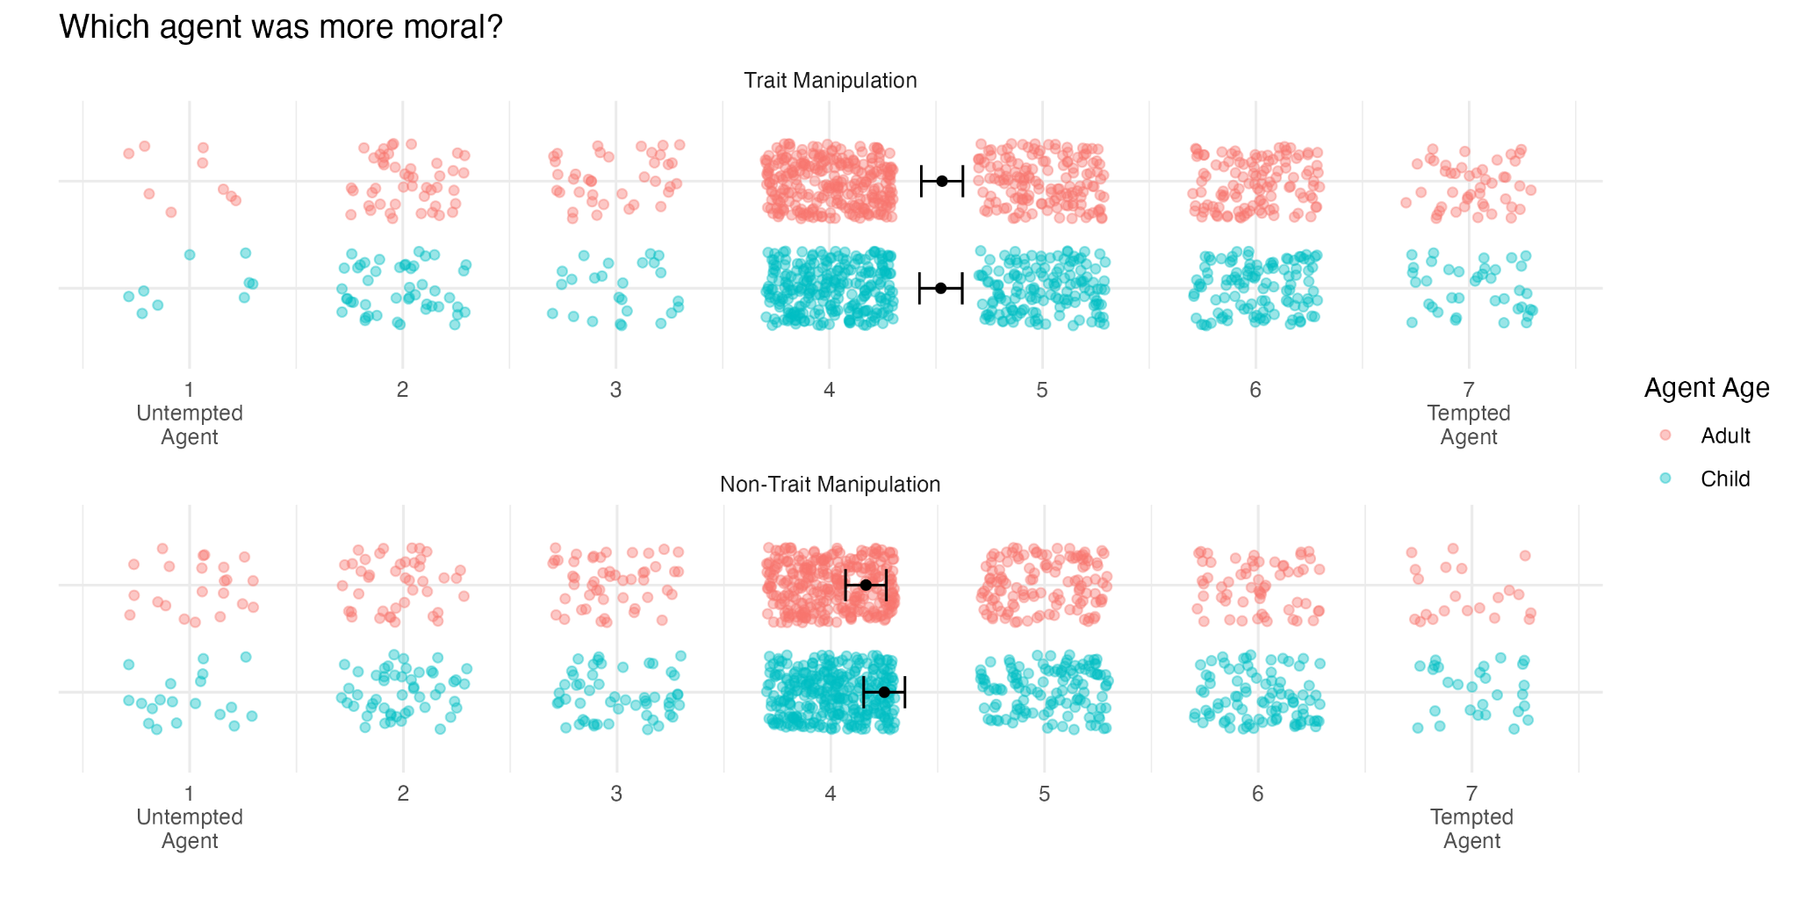
Note. Error bars represent 95% confidence intervals. One dot represents a single rating.

Table 7
Results from t-tests Evaluating whether Mean Relative Morality Ratings Differed from Neutral
Agent Age | Manipulation Type | n | t | df | p
Child | Non-Trait | 679 | 5.091 | 678 | < .001*
Child | Trait | 633 | 10.237 | 632 | < .001*
Adult | Non-Trait | 633 | 3.377 | 632 | < .001*
Adult | Trait | 679 | 10.647 | 678 | < .001*
Note. * Indicates p < .05
Following this up, we conducted one-sample t-tests to determine whether relative morality ratings were significantly different from the neutral midpoint for each level of manipulation type and agent age (pre-registered). These tests showed that participants rated the tempted agent as more moral in all four conditions (see Table 7).
We calculated the number of participants whose average moral praise ratings were greater, equal, and lesser for agents who overcame versus did not experience temptation in both the trait and non-trait manipulation conditions (not pre-registered). We found that in the trait manipulation condition, 63.4% of participants rated agents who overcame temptation higher on average than agents who did not experience temptation. In the non-trait manipulation, 53.4% of participants responded with this pattern. Table 8 shows the full results.

Table 8
Number of Participants with Each Effect of Temptation for Trait and Non-Trait Manipulations
Effect Direction |  | N
Trait Manipulation
 | Untempted Agent More Praiseworthy | 60
 | Agents Equally Moral | 60
 | Tempted Agent More Praiseworthy | 208
Non-Trait Manipulation
 | Untempted Agent More Praiseworthy | 66
 | Agents Equally Moral | 87
 | Tempted Agent More Praiseworthy | 175

5. Study 4
In Study 1, we replicated the direction of the effect from McManus et al. (2024) that tempted agents were seen as less praiseworthy than untempted agents, but not its significance. In Study 2, we replicated the effect from Starmans & Bloom (2016) that agents who overcame temptation were seen as more praiseworthy than agents who did not experience temptation in the first place. In Studies 2 and 3, we also examined two key differences between the paradigms used in the two papers. We found that the age of the agent made no difference in the effect of temptation, and we found that using a non-trait temptation manipulation did move preferences toward the untempted agent, though not enough to reverse the Starmans & Bloom (2016) effect. In Study 4, we aimed to replicate the effect from McManus et al. (2024) and to examine a third key difference between the papers: whether scenarios involved bad behaviors that were morally relevant (“moral” scenarios) or bad behaviors that were morally irrelevant (“nonmoral” scenarios). For example, a moral scenario could involve an agent being tempted to steal a wallet (an action that is morally bad), while a nonmoral scenario could involve temptation to watch TV (an action that is not morally valenced, but that is made “bad” in the context of the scenario). In line with our results and with findings in the literature (Berman & Small, 2018), we hypothesized that for non-moral scenarios, participants would give more praise to agents who overcame temptation, but for moral scenarios, participants would give those agents less praise. In Study 4, we also aimed to test how one individual difference might influence perceptions of tempted and untempted agents. Recent research has developed and validated a Moral Growth Mindset (MGM) scale (Han et al., 2020), which measures the extent to which individuals believe that people can improve their morality. We hypothesized that high MGM people may see overcoming temptation as part of the process of moral growth and therefore wish to encourage tempted agents in that growth by praising them more. This study was pre-registered at https://aspredicted.org/8sjd-nnx6.pdf.

5.1. Methods

5.1.1. Participants
Participants were 400 US adults. Per our pre-registered criteria, 89 participants were excluded from analysis for either failing at least half of the trial-level manipulation checks, finishing the survey in less than half of the median time, or failing the attention check. Additionally, one participant’s data was missing. Thus, the final sample size was 310 (45.81% male, 49.35% female, 1.94% non-binary, 2.90% unknown, M_{age} = 37.15). The study lasted about 14 minutes, and compensation for participation was $2.40.

5.1.2. Materials and Procedure
After consenting to the experiment, participants saw 16 scenarios in which two characters each had to decide between two options in a dilemma. The dilemmas in eight of these scenarios were designed to be non-moral, with a specific focus on making the dilemmas about temptation interfering with agents reaching their personal goals. Some of these were exact copies of scenarios from Study 3, while others were replacements for the scenarios in Study 3 that involved other people. The other eight scenarios were designed to be moral in nature, and all involved the tempted behavior negatively affecting other people in some way. All of these were adapted from Study 1, with minor wording changes to match the style of the Study 3 scenarios. In all scenarios, one agent was described as wanting to do the bad behavior and one was described as not wanting to do the bad behavior, but no information was given about whether agents liked or disliked the tempting behaviors (i.e., only a non-trait manipulation was used). Both agents always ended up choosing the good behavior. Additionally, all agents were adults. Each participant was randomly assigned to one of three options for the order of the scenarios: they either saw all moral scenarios first, all nonmoral scenarios first, or a true randomization of the scenarios. After half of the scenarios, there was an attention check question, which instructed participants to ignore the question wording beneath and select a specific answer instead.
After reading each scenario, participants were asked the exact same questions as they were in Study 3, except that the question about the average likelihood of temptation was replaced with two questions about the overall character of the agents: “How good or bad do you think each individual is in general?” (1 = very bad, 7 = very good). Additionally, either before or after seeing all scenarios, participants filled out the 4-item Moral Growth Mindset scale (Han et al., 2020). This scale measures the extent to which participants believe that individuals are able to improve their moral character. Responses to the four items (e.g., “No matter who you are, you can significantly improve your morals and character.”) are measured on a 6-point Likert scale (1 = strongly disagree, 6 = strongly agree), and a participant’s score on the MGM is the average of their four responses.

5.2. Results
As pre-registered, we conducted a linear mixed effects model with temptation (effect-coded: -0.5 = untempted, 0.5 = tempted) and scenario type (effect-coded: -0.5 = nonmoral, 0.5 = moral) as the independent variables and moral praise as the dependent variable. The model showed a significant effect of temptation, such that untempted agents were given more praise than tempted agents, a significant effect of scenario type, such that agents were given more praise in moral scenarios than nonmoral scenarios, and a significant interaction between the two (see Table 9). Follow up contrasts (not pre-registered) showed that the effect of temptation was significant among moral scenarios (b = 0.449, SE = 0.068, z = 6.614, p < .001), but that there was no significant effect of temptation among nonmoral scenarios (b = -0.044, SE = 0.068, z = -0.642, p = .521). Figure 6 shows moral praise ratings split by temptation and scenario type.

Figure 6
Moral Praise Ratings by Temptation and Scenario Type
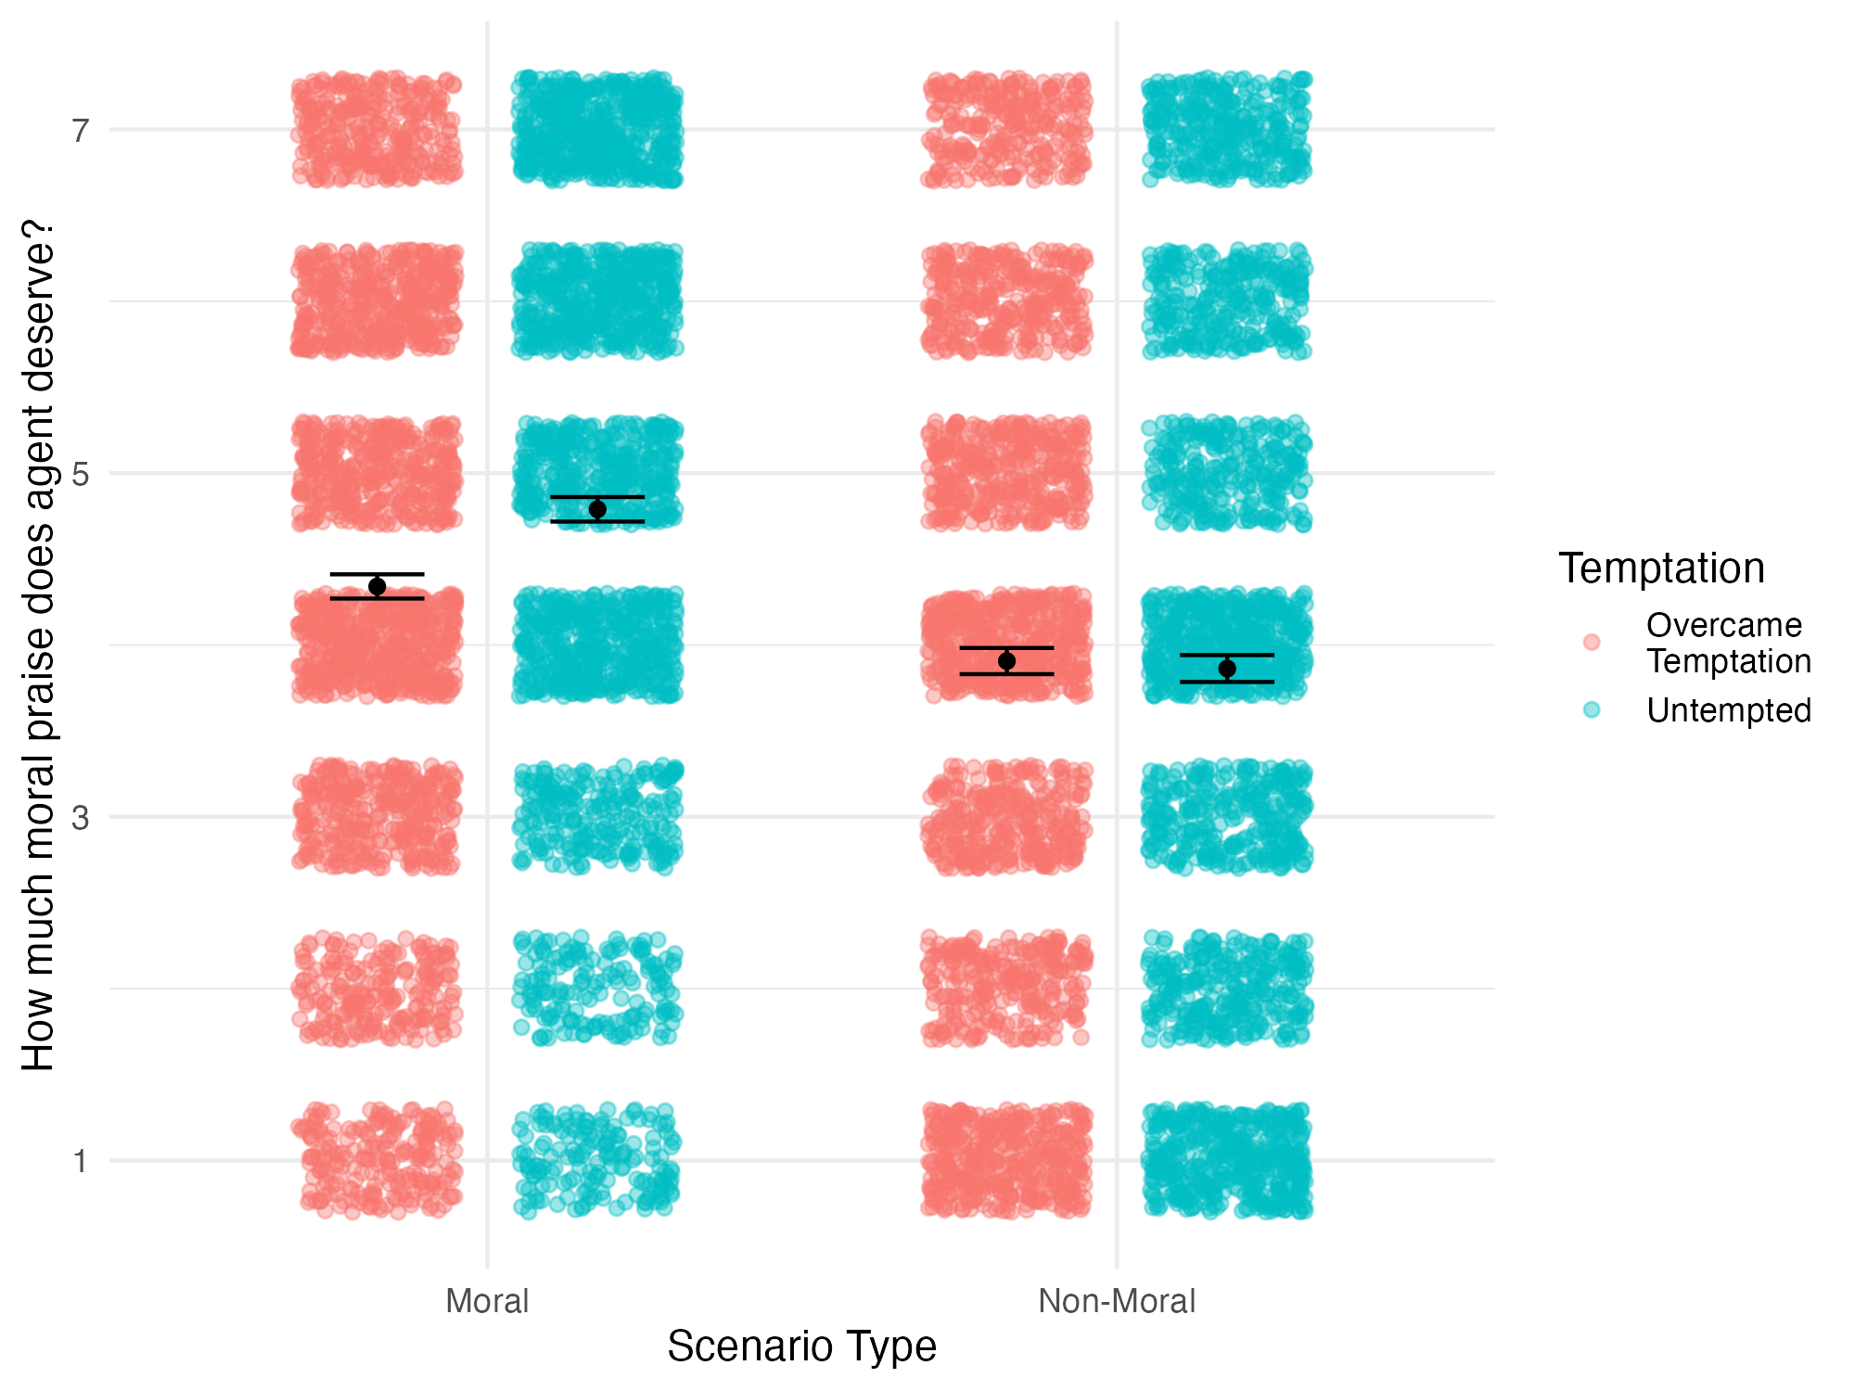
Note. Error bars represent 95% confidence intervals. One dot represents a single rating.

Table 9
Results from the Linear Mixed Effects Model Predicting Moral Praise from Temptation and Scenario Type
Effect | Estimate | SE | df | t | p
Temptation | -0.203 | 0.058 | 100.253 | -3.517 | .001*
Scenario Type | 0.680 | 0.192 | 17.536 | 3.546 | .002*
Temptation * Scenario Type | 0.492 | 0.072 | 18.744 | 6.865 | < .001*
Note. * Indicates p < .05
As pre-registered, we also conducted a linear mixed effects model with scenario type (effect-coded: -0.5 = nonmoral, 0.5 = moral) as the independent variable and relative morality as the dependent variable. The model showed a significant effect of scenario type, b = -0.463, SE = 0.066, t = -7.069, p < .001, such that relative morality ratings were significantly lower in the moral condition than the nonmoral condition. This indicates that participants had a stronger preference for the untempted agent over the tempted agent in the moral scenarios than they did in the nonmoral scenarios. As pre-registered, we also conducted one-sample t-tests to assess whether relative morality ratings were significantly different from the neutral midpoint in both moral and nonmoral scenarios. The tests showed that ratings were significantly below the midpoint (indicating a preference for the untempted agent) in both kinds of scenarios, ts(2487) < -5.066, ps < .001.
As pre-registered, we conducted a Pearson correlation test between MGM scores and person-level effects of temptation on moral praise (this person-level effect is defined as the average of the participant’s moral praise ratings for tempted agents minus the average of their moral praise ratings for non-tempted agents). This test did not reveal a significant relationship between MGM and temptation, r = -0.11, p = .065. We also conducted a Pearson correlation test between MGM scores and person-level average relative morality ratings. This test revealed a significant negative relationship between MGM and relative morality, r = -0.15, p = .007, such that participants higher in MGM tended to rate the untempted agent as more moral overall.
We conducted a linear mixed effects model with temptation (effect-coded: -0.5 = untempted, 0.5 = tempted), scenario type (effect-coded: -0.5 = nonmoral, 0.5 = moral), and scenario order (factor: non-moral scenarios first as the reference level) as the independent variables and moral praise as the dependent variable (not pre-registered). The results of the model are shown in Table 10. Among other effects, there was a significant three-way interaction between scenario type, temptation, and both comparison levels of scenario order. This indicates that the pattern of the two-way interaction between temptation and scenario type depended on the order in which participants saw the scenarios. Follow up contrasts showed that when participants saw all non-moral scenarios first, they rated the untempted agent as more praiseworthy in the moral scenarios (b = -0.252, SE = 0.104, z = -2.42, p = .016) and the tempted agent as more praiseworthy in the non-moral scenarios (b = 0.450, SE = 0.104, z = 4.321, p < .001). However, when participants saw either all moral scenarios first or a fully randomized mix, they still rated the untempted agent as more praiseworthy in the moral scenarios (bs > 0.451, SEs = 0.106, zs > 4.253, ps < .001) but rated both agents equally praiseworthy in the non-moral scenarios (|b|s < 0.136, SEs = 0.106, |z|s < 1.283, ps > 0.200). Additional follow up contrasts showed that for non-moral scenarios, average praise ratings were significantly lower when participants saw all moral scenarios first compared to the other scenario orders (bs > 0.600, SEs < 0.205, zs > 2.913, ps < 0.010). However, for moral scenarios, average praise ratings did not change depending on the order in which scenarios were presented (|b|s < 0.118, SEs > 0.203, |z|s < 0.577, ps > 0.832). Figure 7 shows moral praise ratings split by temptation, scenario type, and scenario order.

Figure 7
Moral Praise Ratings by Temptation, Scenario Type, and Scenario Order
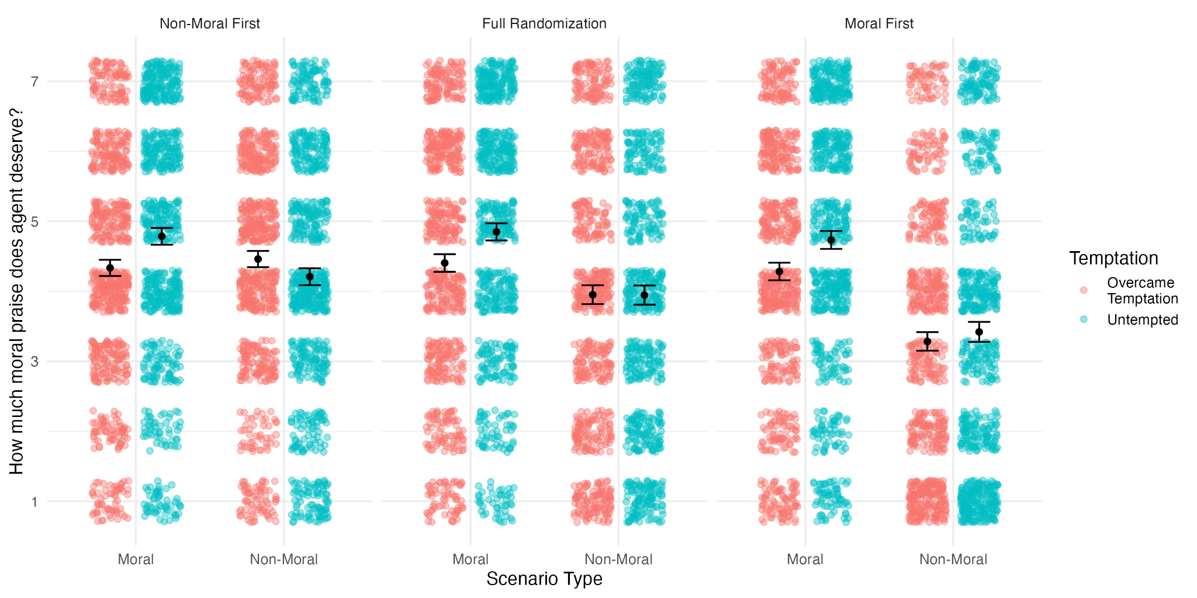
Note. Error bars represent 95% confidence intervals. One dot represents a single rating.

Table 10
Results from the Linear Mixed Effects Model Predicting Moral Praise from Temptation, Scenario Type, and Scenario Order
Effect | Estimate | SE | df | t | p
Scenario Type | 0.225 | 0.21 | 24.883 | 1.074 | .293
Temptation | -0.099 | 0.092 | 250.440 | -1.079 | .282
Scenario Order: Random | -0.160 | 0.188 | 307.003 | -0.849 | .397
Scenario Order: Moral First | -0.517 | 0.188 | 307.003 | -2.752 | .006*
Scenario Type * Temptation | -0.703 | 0.099 | 61.348 | -7.109 | < .001*
Scenario Type * Scenario Order: Random | 0.452 | 0.153 | 306.998 | 2.952 | .003*
Scenario Type * Scenario Order: Moral First | 0.931 | 0.153 | 306.998 | 6.073 | < .001*
Temptation * Scenario Order: Random | -0.120 | 0.126 | 307.004 | -0.956 | .340
Temptation * Scenario Order: Moral First | -0.194 | 0.126 | 307.004 | -1.545 | .123
Scenario Type * Temptation * Scenario Order: Random | 0.252 | 0.121 | 306.999 | 2.087 | .038*
Scenario Type * Temptation * Scenario Order: Moral First | 0.388 | 0.121 | 306.999 | 3.214 | .001*
Note. * Indicates p < .05
We calculated the number of participants whose average moral praise ratings were greater, equal, and lesser for agents who overcame versus did not experience temptation in both the moral and non-moral scenarios, at each level of scenario order (not pre-registered). We found that when non-moral scenarios came first, 53.8% of participants rated the untempted agent as more praiseworthy in moral scenarios, and 55.7% of participants rated the tempted agent as more praiseworthy in non-moral scenarios. However, when moral scenarios came first or scenarios were presented in a random order, 50.5% of participants rated the untempted agent as more praiseworthy in moral scenarios, but only 32.8% of participants rated the tempted agent as more praiseworthy in non-moral scenarios. Table 11 shows the full results.

Table 11
Number of Participants with Each Effect of Temptation for Each Scenario Type and Order
Effect Direction |  | N
Moral Scenarios with Non-Moral Scenarios First
 | Untempted Agent More Praiseworthy | 57
 | Agents Equally Moral | 25
 | Tempted Agent More Praiseworthy | 24
Non-Moral Scenarios with Non-Moral Scenarios First
 | Untempted Agent More Praiseworthy | 23
 | Agents Equally Moral | 24
 | Tempted Agent More Praiseworthy | 59
Moral Scenarios with Moral Scenarios First or Random Mix
 | Untempted Agent More Praiseworthy | 103
 | Agents Equally Moral | 60
 | Tempted Agent More Praiseworthy | 41
Non-Moral Scenarios with Moral Scenarios First or Random Mix
 | Untempted Agent More Praiseworthy | 46
 | Agents Equally Moral | 91
 | Tempted Agent More Praiseworthy | 67

6. Discussion
Across four studies, we expanded our understanding of the relationship between temptation and virtue. Study 1 showed that behavior was a much more important factor in determining judgements of morality than the presence or absence of temptation. In other words, regardless of whether they had to overcome temptation, agents who chose a good behavior were rated as much more moral than agents who chose a bad behavior. This effect may have arisen due to the propensity of people to assume that actions reflect stable traits (Winter & Uleman, 1984) and the strong motivation to assess agents’ character when evaluating the morality of those actions (Pizarro & Tannenbaum, 2012). As our results showed, participants overall tended to think that agents would behave the same way in the future. Therefore, agents who chose the bad behavior were likely generally seen as bad people, and agents who chose the good behavior as good people. Participants may then have been accordingly (un)favorable when rating the morality of the agents’ actions.
Studies 2 and 3 showed that, in non-moral scenarios, participants rated agents who overcame temptation as morally better than agents who never experienced it. Given that the stimuli in these studies were modeled after those of Starmans & Bloom (2016), we take this to mean that their scenarios were indeed non-moral, and that this is the chief reason for their effect being in the direction that it was. Notably, this effect of temptation did not change with agent age, though it was diminished under a non-trait manipulation of temptation (i.e., when untempted agents were more intentional about their decision). The null effect of agent age suggests that, even though participants may have different expectations of the skillfulness of adults and children in making decisions, they still find the same aspects of decision making good and bad. The effect of temptation manipulation type indicates that people are sensitive to the reasons for which agents are able to avoid experiencing desires toward vices. Untempted agents who liked the bad behavior were seen as morally better than untempted agents who disliked the bad behavior. This finding is relevant to an emerging area of research in moral psychology concerning moral bioenhancement—i.e., the potential for moral growth to be aided by technology (Lucas et al., 2024). If participants gave less praise to agents who simply defaulted to good behaviors versus intentionally chose them, this may indicate that people will see technology-aided moral decision makers as inferior or illegitimate.
Study 4 replicated past work by Berman & Small (2018) showing that participants rated untempted agents as better in moral scenarios and tempted agents as better in non-moral scenarios. Further, due to the within-subjects design of the current work, we now understand this effect with novel precision. The two-way interaction between temptation and scenario type was sensitive to the order in which scenarios were presented. Specifically, the interaction as found by Berman & Small (2018) was present only when participants saw all non-moral scenarios first. When participants saw all moral scenarios first (or saw a random mix), they still rated the untempted agent as better in moral scenarios, but rated the agents as equally good on average in non-moral scenarios. Notably, when moral scenarios came first, participants also generally gave lower praiseworthiness ratings to agents in non-moral scenarios, compared to their ratings of those same agents when the non-moral scenarios came first. This may have been caused by participants anchoring on the moral scenarios, which tended to have higher stakes decisions (e.g., to steal or not) compared to the low stakes decisions in non-moral scenarios (e.g., to clean your apartment or not). Overall, these observations suggest that though beliefs about the relative merits of tempted versus untempted agents are replicable for both moral and non-moral scenarios, they are more strongly held in the moral context than the non-moral one.
Study 4 also tested the hypothesis that those higher in MGM would rate tempted agents as better because they may see overcoming temptation as part of the process of moral growth and wish to encourage tempted agents in that growth. However, our data support a different hypothesis: we found a small but significant negative correlation between person-level average relative morality ratings and Moral Growth Mindset (MGM) scores. Overall, relative morality ratings from participants higher in MGM (versus lower in MGM) were closer to the side of the scale that corresponded to the untempted agent being more moral. Further, though not significant, the correlation between MGM scores and person-level effects of temptation on moral praise was in the same direction. These results contrast our original hypothesis. Perhaps instead, people high in MGM feel increased motivation to differentiate between agents who behave in ways that they deem good and bad because they more strongly believe that that information will lead toward moral growth. In other words, those low in MGM, who are less likely to believe that people can improve their morals, may not find value in saying who does and does not need improvement.
The current work does have several limitations that should be noted. The participants in these studies were all from the United States, meaning that it is unclear whether our findings would hold in other countries. Notably, prior work has shown that there is meaningful variability in country-level growth mindset endorsement (Lou & Li, 2023) and that growth mindset endorsement is positively associated with collectivism (and fixed mindset endorsement with individualism) (Tang et al., 2016). Given that Study 4 found a significant relationship between MGM and person-level average relative morality ratings, we believe it is possible that cross-cultural research may reveal that the effect of temptation changes with culture. Future research may explore this possibility.
Additionally, we did not measure virtuosity at every possible combination of the key independent variables that we deemed of theoretical interest. For example, while we ran one study testing the effect of scenario type and two studies testing the effect of agent age, we did not run any studies that simultaneously manipulated these two variables. Therefore, it is possible that there remain interaction effects between these variables that we did not document in the current work. Correspondingly, future research may test for these interactions.
Future research in this area may also go beyond addressing the above limitations. For example, studies may connect back to other theoretical questions raised by previous work. Stamans & Bloom (2016) found that child versus adult participants showed different patterns of responses in their ratings of the tempted and untempted agent (specifically, even though the scenarios were non-moral, children rated the untempted agent as better). Research may investigate whether adults’ and children’s ratings also differ when considering moral scenarios, and how this pattern might develop across the lifespan.
In summary, the present work has expanded our psychological understanding of the relationship between temptation and virtue and unified the past literature on points of disagreement. Our work shows that, in addition to being sensitive to temptation when evaluating behavior, people are also attentive to the reasons behind the presence or absence of that temptation. Further, we showed that, while temptation affects perceptions of goodness differently in the case of moral versus non-moral virtue, beliefs about its implications are held most strongly in the moral domain.

7. Data statement.
All data and code for this work can be found here: https://osf.io/j2f8b/?view_only=33ff851464034665978999604c93522c

8. References
Aristotle. (2019). Nicomachean ethics (T. Irwin, Trans.). Hackett Publishing Company.
Berman, J. Z., & Small, D. A. (2018). Discipline and desire: On the relative importance of willpower and purity in signaling virtue. Journal of Experimental Social Psychology, 76, 220–230. https://doi.org/10.1016/j.jesp.2018.02.007
Critcher, C. R., Inbar, Y., & Pizarro, D. A. (2013). How quick decisions illuminate moral character. Social Psychological and Personality Science, 4(3), 308–315. https://doi.org/10.1177/1948550612457688
Halfon, M. S. (1989). Integrity: A philosophical inquiry. Temple University Press.
Han, H., Dawson, K. J., Choi, Y. R., Choi, Y.-J., & Glenn, A. L. (2020). Development and validation of the English version of the Moral Growth Mindset measure. F1000Research, 9, 256. https://doi.org/10.12688/f1000research.23160.3
Kant, I., Schneewind, J. B., Baron, M., & Kagan, S. (2002). Groundwork for the metaphysics of morals. Yale University Press; JSTOR. http://www.jstor.org/stable/j.ctt1njjwt
Knobe, J., & Nichols, S. (2011). Free will and the bounds of the self. In R. Kane (Ed.), Oxford handbook of free will. New York: Oxford University Press.
Lou, N. M., & Li, L. M. W. (2023). The mindsets × societal norm effect across 78 cultures: Growth mindsets are linked to performance weakly and well‐being negatively in societies with fixed‐mindset norms. British Journal of Educational Psychology, 93(1), 134–152. https://doi.org/10.1111/bjep.12544
Lucas, S., Douglas, T., & Faber, N. S. (2024). How moral bioenhancement affects perceived praiseworthiness. Bioethics, 38(2), 129–137. https://doi.org/10.1111/bioe.13237
McManus, R. M., Padilla Fong, H., Kleiman-Weiner, M., & Young, L. (2024). Most people do not “value the struggle”: Tempted agents are judged as less virtuous than those who were never tempted. Journal of Experimental Social Psychology, 113, 104615. https://doi.org/10.1016/j.jesp.2024.104615
McManus, R. M., Young, L., & Sweetman, J. (2023). Psychology Is a property of persons, not averages or distributions: Confronting the group-to-person generalizability problem in experimental psychology. Advances in Methods and Practices in Psychological Science, 6(3). https://doi.org/10.1177/25152459231186615
Nahmias, E., Coates, J., & Kvaran, T. (2007). Free will, moral responsibility, and mechanism: Experiments on folk intuitions. Midwest Studies in Philosophy, 31, 214–242.
Pizarro, D. A., & Tannenbaum, D. (2012). Bringing character back: How the motivation to evaluate character influences judgments of moral blame. In M. Mikulincer & P. R. Shaver (Eds.), The social psychology of morality: Exploring the causes of good and evil. (pp. 91–108). American Psychological Association. https://doi.org/10.1037/13091-005
Starmans, C., & Bloom, P. (2016). When the spirit Is willing, but the flesh is weak: Developmental differences in judgments about inner moral conflict. Psychological Science, 27(11), 1498–1506. https://doi.org/10.1177/0956797616665813
Tang, M., Werner, C., & Karwowski, M. (2016). Differences in creative mindset between Germany and Poland: The mediating effect of individualism and collectivism. Thinking Skills and Creativity, 21, 31–40. https://doi.org/10.1016/j.tsc.2016.05.004
Taylor, G., & Gaita, R. (1981). Integrity. Aristotelian Society Supplementary Volume, 55(1), 143–176. https://doi.org/10.1093/aristoteliansupp/55.1.143
Winter, L., & Uleman, J. S. (1984). When are social judgments made? Evidence for the spontaneousness of trait inferences. Journal of Personality and Social Psychology, 47(2), 237–252. https://doi.org/10.1037//0022-3514.47.2.237

